Hi All,
93
This morning’s reading in HPB’s Isis Unveiled, Vol. II, Cap. 9 leads me to a reinvestigation of the Moebius Ribbon that is connected with Crowley’s returning Atus VIII and XI to their original position.

Nearly all the prophecies about Christ are credited to the patriarchs and prophets. If a few of the latter may have existed as real personages, every one of the former is a myth. We will endeavor to prove it by the hidden interpretation of the Zodiac, and the relations of its signs to these antediluvian men.
If the reader will keep in mind the Hindu ideas of cosmogony, as given in chapter vi., he will better understand the relation between the biblical antediluvian patriarchs, and that puzzle of commentators -- "Ezekiel's wheel." Thus, be it remembered 1, that the universe is not a spontaneous creation, but an evolution from pre-existent matter; 2, that it is only one of an endless series of universes; 3, that eternity is pointed off into grand cycles, in each of which twelve transformations of our world occur, following its partial destruction by fire and water, alternately. So that when a new minor period sets in, the earth is so changed, even geologically, as to be practically a new world; 4, that of these twelve transformations, the earth after each of the first six is grosser, and everything on it -- man included -- more material, than after the preceding one: while after each of the remaining six the contrary is true, both earth and man growing more and more refined and spiritual with each terrestrial change; 5, that when the apex of the cycle is reached, a gradual dissolution takes place, and every living and objective form is destroyed. But when that point is reached, humanity has become fitted to live subjectively as well as objectively. And not humanity alone, but also animals, plants, and every atom. After a time of rest, say the Buddhists, when a new world becomes self-formed, the astral souls of animals, and of all beings, except such as have reached the highest Nirvana; will return on earth again to end their cycles of transformations, and become men in their turn.

This is not all that different from what I state in my article: Gnostic Cycles, in which Manifestations are periods of time in which as Blavatsky puts it, “twelve transformations of our world occur.” Each of these Manifestations are broken down into three astrological ages with the Manifestations moving deosil on the wheel and the Ages moving widdershins. As a reminder, our present Manifestation of Sagittarius is currently in the Age of Pisces; comprising Pisces, Aquarius and Capricorn.

This stupendous conception, the ancients synthesized for the instruction of the common people, into a single pictorial design -- the Zodiac, or celestial belt. Instead of the twelve signs now used, there were originally but ten known to the general public, viz.: Aries, Taurus, Gemini, Cancer, Leo, Virgo-Scorpio, Sagittarius, Capricornus, Aquarius, and Pisces. (In Volney's "Ruins of Empires" p. 360, it is remarked that as Aries was in its fifteenth degree 1447 B. C., it follows that the first degree of "Libra" could not have coincided with the Vernal equinox more lately than 15,194 years B. C., to which, if you add 1790 years since Christ, it appears that 16,984 years have elapsed since the origin of the Zodiac.) These were exoteric. But in addition there were two mystical signs inserted, which none but initiates comprehended, viz.: at the middle or junction-point where now stands Libra, and at the sign now called Scorpio, which follows Virgo. When it was found necessary to make them exoteric, these two secret signs were added under their present appellations as blinds to conceal the true names which gave the key to the whole secret of creation, and divulged the origin of "good and evil."
The true Sabean astrological doctrine secretly taught that within this double sign was hidden the explanation of the gradual transformation of the world, from its spiritual and subjective, into the "two-sexed" sublunary state.

What HPB is stating in really, what amounts to a poorly written description, is that a sign was inserted between Virgo and Scorpio; where now sits Libra and which itself is a dual sign as indicated by the symbol of scales that are attributed to it. The symbols for both Virgo and Scorpio have as their main body, what looks like the letter M, which interestingly enough is connected to the indication of the lost Word: M…M.

Virgo is opposite Pisces on the Zodiacal wheel; Pisces being the sign that starts the present Manifestation. And Virgo without the interruption of Libra, would be posited right next to Scorpio. And so with Libra being dualistic in nature, and representing karma (mistakenly interpreted as good and evil), we have an appropriate metaphor for the two genders of HPB’s “sublunary state”, wherein spirit manifests on the material plane. The fact that this mystery ultimately comes to be revealed to the profane, through the Greeks is very important; timing-wise. Their culture flourished immediately before the onset of the new Manifestation with its opening Age; Pisces. Virgo and Pisces are the key signs that Crowley used in restoring the Atus of the Holy Tarot, back to their original order.

Here’s Crowley’s depiction of the Moebius Ribbon:

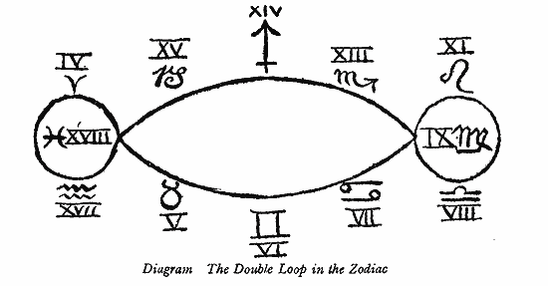

Note that the Zodiacal wheel is twisted on both ends at Virgo and Pisces, inverting Leo and Libra on the Virgoan end and Aries and Aquarius on the Piscean end. This is of course, well explained in Crowley’s writings on the subject. We can also find a hint for the original ten signs in the naming of the months; today, our last four months in Latin are Septem, Octem, Novem, Decem or seven, eight, nine and ten; indicating that there was originally, a ten month calendar for the year.

The twelve signs were therefore divided into two groups. The first six were called the ascending, or the line of Macrocosm (the great spiritual world); the last six, the descending line, or the Microcosm (the little secondary world) -- the mere reflection of the former, so to say. This division was called Ezekiel's wheel, and was completed in the following way: First came the ascending five signs (euphemerized into patriarchs), Aries, Taurus, Gemini, Cancer, Leo, and the group concluded with Virgo-Scorpio. Then came the turning-point, Libra. After which, the first half of the sign Virgo-Scorpio, was duplicated and transferred to lead the lower, or descending group of Microcosm which ran down to Pisces, or Noah (deluge). To make it clearer, the sign Virgo-Scorpio, which appeared originally thus , became simply Virgo, and the duplication, , or Scorpio, was placed between Libra, the seventh sign (which is Enoch, or the angel Metatron, or Mediator between spirit and matter, or God and man). It now became Scorpio (or Cain), which sign or patriarch led mankind to destruction, according to exoteric theology; but, according to the true doctrine of the wisdom-religion, it indicated the degradation of the whole universe in its course of evolution downward from the subjective to the objective.
The sign of Libra is credited as a later invention by the Greeks, but it is not generally stated that those among them who were initiated had only made a change of names conveying the same idea as the secret name to those "who knew," leaving the masses as unwise as ever. Yet it was a beautiful idea of theirs, this Libra, or the balance, expressing as much as could possibly be done without unveiling the whole and ultimate truth. They intended it to imply that when the course of evolution had taken the worlds to the lowest point of grossness, where the earths and their products were coarsest, and their inhabitants most brutish, the turning-point had been reached -- the forces were at an even balance. At the lowest point, the still lingering divine spark of spirit within began to convey the upward impulse. The scales typified that eternal equilibrium which is the necessity of a universe of harmony, of exact justice, of the balance of centripetal and centrifugal forces, darkness and light, spirit and matter.

The following diagram represents Ezekiel's Wheel, as given in many works, among others, in Hargrave Jennings' Rosicrucians:

EZEKIEL'S WHEEL (exoteric).
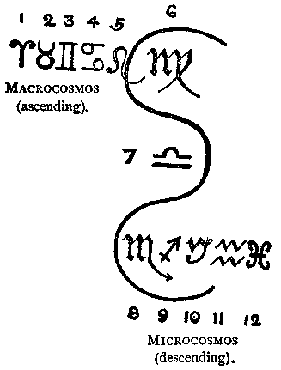

These signs are (follow numbers):

1, Aries; 2, Taurus; 3, Gemini; 4, Cancer; 5, Leo; 6, Virgo, or the ascending line of the grand cycle of creation. After this comes 7, Libra -- "man," which, though it is found right in the middle, or the intersection point, leads down the numbers:
8, Scorpio; 9, Sagittarius; 10, Capricornus; 11, Aquarius; and 12, Pisces.

That Virgo becomes the point for the original twist on the Zodiacal wheel, is clearly delinated in HPB’s diagram; bringing Virgo next to Scorpio as also shown on Crowley’s diagram. The Virgo-Scorpio connection is then clearly shown and we see why sex and death have been strong themes in this Age of Pisces.

While discussing the double sign of Virgo-Scorpio and Libra, Hargrave Jennings observes (p. 65):
"All this is incomprehensible, except in the strange mysticism of the Gnostics and the kabalists; and the whole theory requires a key of explanation to render it intelligible; which key is only darkly referred to as possible, but refused absolutely, by these extraordinary men, as not permissible to be disclosed."
The said key must be turned seven times before the whole system is divulged. We will give it but one turn, and thereby allow the profane one glimpse into the mystery. Happy he, who understands the whole!

EZEKIEL'S WHEEL (esoteric).
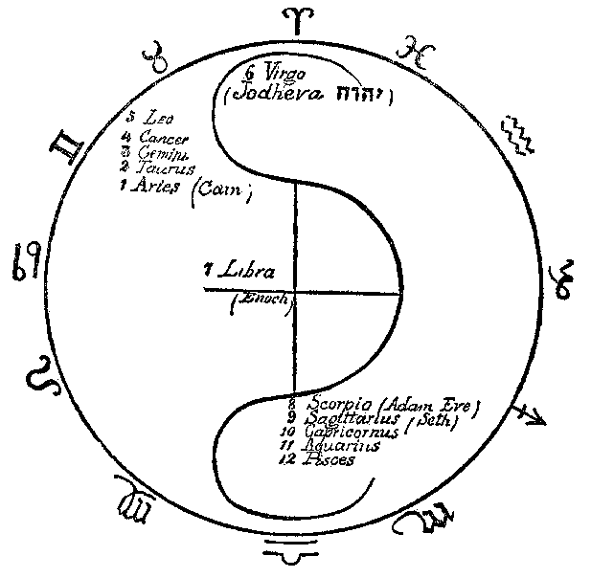
To explain the presence of Jodheva (or Yodheva), or what is generally termed the tetragram , and of Adam and Eve, it will suffice to remind the reader of the following verses in Genesis, with their right meaning inserted in brackets.
1. "And God [Elohim] created man in his [their] own image . . . male and female created he them [him]" -- (ch. 1. 27).
2. "Male and female created he them [him] . . . and called their [his] name ADAM" -- (v. 2).

When the ternary is taken in the beginning of the tetragram, it expresses the divine creation spiritually, i.e., without any carnal sin: taken at its opposite end it expresses the latter; it is feminine. The name of Eve is composed of three letters, that of the primitive or heavenly Adam, is written with one letter, Jod or Yodh; therefore it must not be read Jehova but Ieva, or Eve. The Adam of the first chapter is the spiritual, therefore pure androgyne, Adam Kadmon. When woman issues from the left rib of the second Adam (of dust), the pure Virgo is separated, and falling "into generation," or the downward cycle, becomes Scorpio, (Scorpio is the astrological sign of the organs of reproduction.) emblem of sin and matter. While the ascending cycle points at the purely spiritual races, or the ten prediluvian patriarchs (the Pradjapatis, and Sephiroth) [The patriarchs are all convertible in their numbers as well as interchangeable. According to what they relate, they become ten, five, seven, twelve, and even fourteen. The whole system is so complicated that it is an utter impossibility in a work like this to do more than hint at certain matters.] are led on by the creative Deity itself, who is Adam Kadmon or Yodcheva, the lower one is that of the terrestrial races, led on by Enoch or Libra, the seventh; who, because he is half-divine, half-terrestrial, is said to have been taken by God alive. Enoch, or Hermes, or Libra are one.

Connecting Enoch to the generation of the Nephilim seems almost apparent here. Libra, the seventh sign is connected with the number of generation, seven (the seven planets being the principal gods generated from the ONE). That this physical being (Enoch) is taken to ‘heaven’ (the astral plane) shows that he leads the legions of Nephilim that are alleged to be ‘trapped’ there, but are indeed there awaiting each, their human charge in order to further educated them in spiritual matters: being one for each of us, our Holy Guardian Angel.

All are the scales of universal harmony; justice and equilibrium are placed at the central point of the Zodiac. The grand circle of the heavens, so well discoursed upon by Plato, in his Timaeus, symbolizes the unknown as a unity; and the smaller circles which form the cross, by their division on the plane of the Zodiacal ring -- typify, at the point of their intersection, life. The centripetal and centrifugal forces, as symbols of Good and Evil, Spirit and Matter, Life and Death, are also those of the Creator and the Destroyer, -- Adam and Eve, or God and the Devil, as they say in common parlance. In the subjective, as well as in the objective worlds, they are the two powers, which through their eternal conflict keep the universe of spirit and matter in harmony. They force the planets to pursue their paths, and keep them in their elliptical orbits, thus tracing the astronomical cross in their revolution through the Zodiac. In their conflict the centripetal force, were it to prevail, would drive the planets and living souls into the sun, type of the invisible Spiritual Sun, the Paraatma or great universal Soul, their parent; while the centrifugal force would chase both planets and souls into the dreary space, far from the luminary of the objective universe, away from the spiritual realm of salvation and eternal life, and into the chaos of final cosmic destruction, and individual annihilation. But the balance is there, ever sensitive at the intersection point. It regulates the action of the two combatants, and the combined effort of both, causes planets and "living souls" to pursue a double diagonal line in their revolution through Zodiac and Life; and thus preserving strict harmony, in visible and invisible heaven and earth, the forced unity of the two reconciles spirit and matter, and Enoch is said to stand a "Metatron" before God. Reckoning from him down to Noah and his three sons, each of these represent a new "world," i.e., our earth, which is the seventh (See vol. I. of the present work, p. 32. Alone, the Hindu calculation by the Zodiac, can give a key to the Hebrew chronologies and the ages of the patriarchs. If we bear in mind that, according to the former astronomical and chronological calculations, out of the fourteen manwantara (or divine ages), each of which composed of twelve thousand years of the devas, multiplied by seventy-one, forms one period of creation -- not quite seven are yet passed, the Hebrew calculation will become more clear. To help, as much as possible, those who will be sure to get a good deal bewildered in this calculation, we will remind the reader that the Zodiac is divided into 360 degrees, and every sign into thirty degrees; that in the Samaritan Bible the age of Enoch is fixed at 360 years; that in "Manu," the divisions of time are given thus: "The day and the night are composed of thirty Mouhourta. A mouhourta contains thirty kalas. A month of the mortals is of thirty days, but it is but one day of the pitris. . . . A year of the mortals is one day of the Devas.") after every period of geological transformation, gives birth to another and distinct race of men and beings.
Cain leads the ascending line, or Macrocosm, for he is the Son of the "Lord," not of Adam (Genesis iv. 1). The "Lord" is Adam Kadmon, Cain, the Son of sinful thought, not the progeny of flesh and blood, Seth on the other hand is the leader of the races of earth, for he is the Son of Adam, and begotten "in his own likeness, after his image" (Genesis v. 3). Cain is Kenu, Assyrian, and means eldest, while the Hebrew word means a Smith, an artificer.
Our science shows that the globe has passed through five distinct geological phases, each characterized by a different stratum, and these are in reverse order, beginning with the last: 1. The Quaternary period, in which man appears as a certainty; 2. The Tertiary period, in which he may have appeared; 3. Secondary period, that of gigantic saurians, the megalosaurus, icthyosaurus, and plesiosaurus -- no vestige of man; 4. The Palaeozoic period, that of gigantic crustacea; 5 (or first). The Azoic period, during which science asserts organic life had not yet appeared.
And is there no possibility that there was a period, and several periods, when man existed, and yet was not an organic being -- therefore could not have left any vestige of himself for exact science? Spirit leaves no skeletons or fossils behind, and yet few are the men on earth who doubt that man can live both objectively and subjectively. At all events, the theology of the Brahmans, hoary with antiquity, and which divides the formative periods of the earth into four ages, and places between each of these a lapse of 1,728,000 years, far more agrees with official science and modern discovery than the absurd chronological notions promulgated by the Councils of Nice and Trent.

Returning to Crowley’s glyph, and tracing a cross upon it, we come to our present situation and the present mundane Aeon of Horus that exists within the Age of Pisces. The Virgo-Pisces line traces the horizontal line of the cross between them. And the Sagittarius-Gemini alignment on the glyph traces the vertical arm of the Cross. As found in my article: Golden Dawn Skies, the Age of Gemini is the age during which the Deluge occurred; wiping away the old knowledge and setting up what would ultimately come together in the Sagittarian Manifestation. These then become two sides of the same coin.

That Crowley returns Libra back to its original position in the Tarot; along with Leo is as now, well known to Thelemites, the necessary reflection of transposing Tzaddi by removing it from the Star Atu (Aquarius) and placing it in the Emperor Atu (Aries) again, is designated by the Moebius Ribbon. Leo, the Sun is depictive of the solar-phallic religion that is the primordial religion of humanity. And Libra of course, carries the genealogy of this ancient and yet eternal religion through the Nephilim as championed by Enoch. The Sun is a star in a company of stars, wherein the Star Atu gives us this ancient truth; relating back to humanity and the Emperor Atu as we are each kings ruling our own destiny.
93/93
pj

