The Unicursal Hexagram
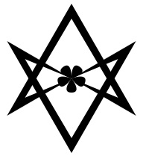
Having recently read this on a Golden Dawn website, it seems important to bring clarity to this important Thelemic symbol.
The Unicursal Hexagram is widely believed to have been created by Aleister Crowley, but the reality is that it is a form introduced in a paper called Polygons and Polygrams, one of seven papers given out in the 4=7 grade of the Golden Dawn. Regardie did not publish this in its entirety, so it is not surprising there is some confusion, but the nature of this symbol according to the Golden Dawn is a bit different to what many Thelemites turned it into.
As the image shows, this is not just another way to draw a standard hexagram, allowing for a single united line, but rather a symbol that denotes something entirely different. It is arguably more alchemical than planetary.
It is classified as the third form of the hexangle and is called the "pseudo-hexagram" or "irregular third form." Its description is: "Denotes the presidency of the Sun and Moon over the Four Elements, united in, and proceeding from, the Spirit."
It is not, therefore, a good replacement for the hexagrams used in the Ritual of the Hexagram, as the only planets concerned are the Sun and Moon, and the Sun is no longer the central focus point, but an opposing force to the Moon, which is its sister and twin.
I maintain that Crowley never claimed this, but claimed that he found an old mathematical symbol that solved the problem of tracing hexagrams and having to draw them as two separate triangles. Though I can’t find the quote, which is very frustrating as I have a clear memory of reading this. However, I managed to find this online:
[Giordano] Bruno included an early version of the unicursal hexagram in this "Figura Amoris", one of a series of allegorized geometrical constructions presented in woodcuts (said to have been prepared by the author's own hands) for Articuli Centum et Sexaginta Adversus huius Tempestatis Mathematicos atque Philosophos [Essays upon the Mathematics of Mordente: One Hundred and Sixty Articles against the Mathematicians and Philosophers of this Age . . . (Prague: 1588), a treatise on techniques of geometrical draftsmanship.
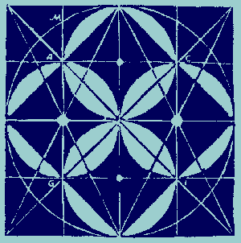

The hexagram is drawn with a five-petaled rose in its center, which is itself, a Rosicrucian symbol; symbolizing the Pentagram and representing the five elements. The rose being sacred to Venus and Isis shows the goddess-centered nature of Thelemic doctrine as it delineates the formula of love under will. The metal of Venus is copper, of which the Wand is forged by the Aspirant in Thelemic Magick; giving us a full expression of this formula.

