The Tarot of Eliphas Levi

These Tarot descriptions are found in The Book of Hermes, comprizing the Chapter XXII in The Ritual of Transcendental Magic, by Eliphas Levi.
(Eliphas Levi. Transcendental Magic, Its Doctrine and Rirual. Translated, annotated and introduced by Arthur Edward Waite. Samuel Weiser, New York, 1979. The original French edition, Rituel de la haute magie, was published in 1855.)
The images of The Charioth and The Devil/Baphomet are taken from the same book. It is widely believed that they are the two only Tarot images left after Levi. This page shows that there are in fact three more Major Arcana in Levi's published books.

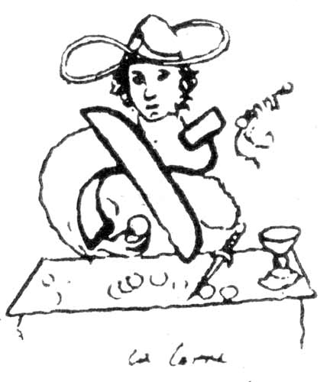  See Note 1 | 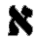 Being, mind, man, or God; the comprehensible object; unity mother of numbers, the first substance.  All these ideas are expressed hieroglyphically by the figure of the JUGGLER. His body and arms constitute the letter ALEPH; round his head there is a nimbus in the form of , emblem of life and the universal spirit; in front of him are swords, cups and pantacles; he uplifts the miraculous rod towards heaven. He has a youthful figure and curly hair, like Apollo or Mercury; the smile of confidence is on his lips and the look of intelligence in his eyes.  On the first page of the Book of Hermes the adept is depicted with a large hat, which, if turned down, would conceal his entire head. One hand is raised towards heaven, which he seems to command with his wand, while the other is placed upon his breast; before him are the chief symbols or instruments of science, and he has others hidden in a juggler's wallet. His body and arms form the letter ALEPH, the first of that alphabet which the Jews borrowed from the Egyptians: to this symbol we shall have occasion to recur later on...  All religions are summed up in the unity of a single dogma, which is the affirmation of being and its equality with itself, and this constitutes its mathematical value. There is only one dogma in Magic, and it is this: The visible is the manifestation of the invisible, or, in other terms, the perfect word, in things appreciable and visible, bears an exact proportion to the things which are inappreciable by our senses and unseen by our eyes. The Magus raises one hand towards heaven and points down with the other to earth, saying: вЂњAbove, immensity: Below immensity still! Immensity equals immensity.вЂќ -- This is true in things seen, as in things unseen.
The House of God and man, the Sanctuary, the law, Gnosis, Kabalah, the Occult Church, the duad, wife, mother.
Hieroglyph of the Tarot: THE FEMALE POPE, a woman crowned with a tiara, wearing the horns of the Moon and Isis, her head enveloped in g mantle, the solar cross on her breast, and holding a book on her knees, which she conceals with her mantle. The protestant author of a pretended history of Pope Joan has met with, and used, for good or bad, in the interests of his thesis, two curious and ancient figures of the Female Pope or Sovereign Priestess of the Tarot. These figures ascribe to her all the attributes of Isis; in one she is carrying and caressing her son Horus; in the other she has long and unbound hair. She is seated between the two Pillars of the duad, has a sun with four rays on her breast, places one hand upon a book and makes the sign of sacerdotal esotericism with the other -- that is to say, she uplifts three fingers only, the two others being folded, to signify mystery. A veil is thrown behind her head, and on each side of her chair the flowers of the lotus bloom upon the sea. I commiserate sincerely the ill-starred scholar who has seen in this antique symbol nothing but a monumental portrait of his pretended Pope Joan.
In the hieroglyphic work of Hermes, being the Tarot or Book of Thoth, the duad is represented either by the horns of Isis, who has her head veiled and an open book concealed partially under her mantle, or otherwise by a sovereign lady, Juno, the Greek goddess, with one hand uplifted towards heaven and the other pointed to earth, as if formulating by this gesture the one and twofold dogma
which is the foundation of Magic and begins the marvellous symbols of the "Emerald Table" of Hermes. 1-2
The word, the triad, plenitude, fecundity, Nature, generation in the three worlds.
Symbol, THE EMPRESS, a woman, winged, crowned, seated and uplifting a sceptre with the orb of the world at end: her sign is an eagle, image of the soul and of life. She is the Venus-Urania of the Greeks and was represented by St John in his Apocalypse as the Woman clothed with the Sun, crowned with twelve stars and having the moon beneath her feet. She is the mystical quintessence of the triad she is spirituality, immortality, the Queen of Heaven.
The porte or government of the easterns, initiation, power, the Tetragram, the quaternary, the cubic stone, or its base.
Hieroglyph, THE EMPEROR, a sovereign whose body represents a right-angled triangle and his legs a cross -- image of the Athanor of the philosophers.
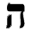 Indication, demonstration, instruction, law, symbolism, philosophy, religion.
Hieroglyph, THE POPE, or grand hierophant. In more modern Tarots this sign is replaced by the image of Jupiter. The grand hierophant, seated between the two Pillars of Hermes and of Solomon, makes the sign of esotericism and leans upon a Cross with three crossbars of triangular form. Two inferior ministers kneel before him. Having above him the capitals of the two Pillars and below him the two heads of the assistants, he is thus the centre of the quinary and represents the divine Pentagram, giving its complete meaning. As a fact, the Pillars are necessity or law, the heads liberty or action. A line may be drawn from each Pillar to each head and two lines from each Pillar to each of the two heads. This gives a square, divided by a cross into four triangles and in the middle of this cross is the grand hierophant, we might almost say like the garden spider in the centre of his web, were such a comparison becoming to the things of truth, glory and light.
In the collection of the talismans of Paracelsus, Jupiter is represented by a priest in ecclesiastical garb, while in the Tarot he appears as a grand hierophant crowned with a triple tiara, holding a three-barred cross in his hands, forming the magical triangle, and representing at once the sceptre and key of the three worlds.
--DR 1-7
Sequence, interlacement, lingam, entanglement, union, embrace, strife, antagonism, combination, equilibrium.
Hieroglyph, man between VICE AND VIRTUE. Above him shines the Sun of Truth, and in this Sun is Love, bending his bow and threatening Vice with his shaft. In the order of the ten SEPHIROTH, this symbol corresponds to TIPHERETH -- that is, to idealism and beauty. The number six represents the antagonism of the two triads, that is, absolute negation and absolute affirmation. It is therefore the number of toil and liberty, and for this reason it connects also with moral beauty and glory.
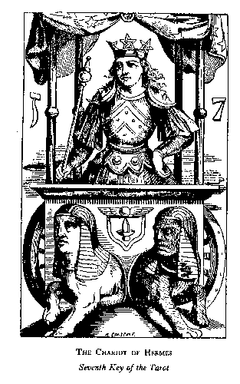 | Weapon, sword, cherubic sword of fire, the sacred septenary, triumph, royalty, priesthood.  Hieroglyph, a CUBIC CHARIOT, with four pillars and an azure and starry drapery. In the chariot, between the four pillars, a victor crowned with a circle adorned with three radiant golden pentagrams. Upon his breast are three superposed squares, on his shoulders the URIM and THUMMIM of the sovereign sacrificer, represented by the two crescents of the moon in GEDULAH and GEBURAH; in his hand is a sceptre surmounted by a globe, square and triangle: his attitude is proud and tranquil. A double sphinx or two sphinxes joined at the haunches are harnessed to the chariot; they are pulling in opposite directions, but are looking the same way. They are respectively black and white. On the square which forms the fore part of the chariot is the Indian lingamsurmounted by the flying sphere of the Egyptians. This hieroglyph, which we reproduce exactly, is perhaps the most beautiful and complete of all those that are comprised in the Clavicle of the Tarot.  THE septenary is the sacred number in all theogonies and in all symbols, because it is composed of the triad and the tetrad. The number seven represents magical power in all its fullness; it is the mind reinforced by all elementary potencies; it is the soul served by Nature; it is the SANCTUM REGNUM mentioned in the Keys of Solomon and represented in the Tarot by a crowned warrior, who bears a triangle on his cuirass and is posed upon a cube, to which two sphinxes are harnessed, straining in opposite directions, while their heads are turned the same way. This warrior is armed with a fiery sword and holds in his left hand a sceptre surmounted by a triangle and a sphere. The cube is the Philosophical Stone; the sphinxes are the two forces of the Great Agent, corresponding to JAKIN and BOAZ, the two Pillars of the Temple; the cuirass is the knowledge of Divine Things, which renders the wise man invulnerable to human assaults; the sceptre is the Magic Wand; the fiery sword is the symbol of victory over the deadly sins, seven in number, like the virtues, the conceptions of both being typified by the ancients under the figures of the seven planets then known. 1-7
Balance, attraction and repulsion, life, terror, promise and threat.
Hieroglyph, JUSTICE with sword and balance.
Good, horror of evil, morality, wisdom.
Hieroglyph, a sage leaning on his staff, holding a lamp in front of him and enveloped completely in his cloak. The inscription is THE HERMIT or CAPUCHIN, on account of the hood of his oriental cloak. His true name, however, is PRUDENCE, and he thus completes the four cardinal virtues which seemed imperfect to Court de Gebelin and Etteilla.
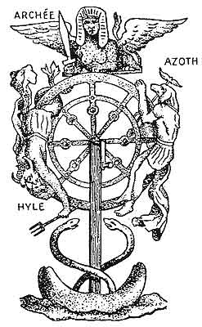  See Note 2 | Principle, manifestation, praise, manly honour, phallus, virile fecundity, paternal sceptre.  Hieroglyph, THE WHEEL OF FORTUNE, that is to say, the cosmogonical wheel of Ezekiel, with a Hermanubis ascending on the right, a Typhon descending on the left and a sphinx in equilibrium above, holding a sword between his lion's claws-an admirable symbol, disfigured by Etteilla, who replaced Typhon by a wolf, Hermanubis by a mouse, and the sphinx by an ape, an allegory characteristic of Etteilia's Kabalah.
The hand in the act of grasping and holding.
Hieroglyph, STRENGTH, a woman crowned with the vital closes, quietly and without effort, the jaws of a raging lion.
Example, instruction, public teaching.
Symbol, a man hanging by one foot, with his hands bound behind his back, so that his body makes a triangle, apex downwards, and his legs a cross above the triangle. The gallows is in the form of a Hebrew TAU, and the two uprights are trees, from each of which six branches have been lopped. We have explained already this symbol of sacrifice and the finished work.

(The Tarot symbol which corresponds to this chapter was misconstrued by Court de Gebelin and Etteilla, who regarded it as the blunder of a German cardmaker. It represents a man with his hands bound behind him, having two bags of money attached to the armpits, and suspended by one foot from a gibbet formed by the trunks of two trees, each with the stumps of six lopped branches, and by a crosspiece, thus completing the figure of the Hebrew TAU . The legs of the victim are crossed, while his head and elbows form a triangle. Now, the triangle surmounted by a cross signifies in alchemy the end and perfection of the Great Work, a meaning which is identical with that of the letter TAU, the last of the sacred alphabet. This Hanged Man is, consequently, the adept, bound by his engagements and spiritualized, that is, having his feet turned towards heaven. He is also the antique Prometheus, expiating by everlasting torture the penalty of his glorious theft. Vulgarly, he is the traitor Judas, and his punishment is a menace to betrayers of the Great Arcanum. Finally, for Kabalistic Jews, the Hanged Man, who corresponds to their twelfth dogma, that of the promised Messiah, is a protestation against the Saviour acknowledged by Christians, and they seem to say unto Him still: How canst Thou save others, since Thou couldst not save Thyself? -- Vol. I, Ch. XII.)

(The twelfth Key represents a man hanging by one foot from a gibbet composed of three trees or posts, forming the Hebrew letter m; the man's arms and head constitute a triangle, and his entire hiero-glyphical shape is that of a reversed triangle surmounted by a cross, an alchemical symbol known to all adepts and representing the accomplishment of the Great Work. -- Vol. II, Ch. XII.)
The heaven of Jupiter and Mars, domination and force, new birth, creation and destruction.
Hieroglyph, DEATH, reaping crowned heads in a meadow where men are growing.
The heaven of the Sun, climates, seasons, motion, changes of life, which is ever new yet ever the same.
Hieroglyph, TEMPERANCE, an angel with the sign of the sun upon her forehead, and on the breast the square and triangle of the septenary, pours from one chalice into another the two essences which compose the Elixir of Life.
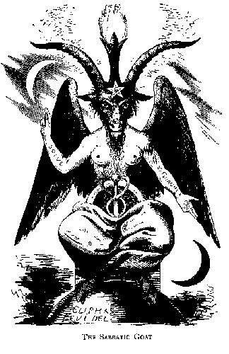 | The heaven of Mercury, occult science, Magic, commerce, eloquence, mystery, moral force.  Hieroglyph, THE DEVIL, the Coat of Mendes, or the Baphomet of the Temple, with all his pantheistic attributes. This is the only hieroglyph which was properly understood and interpreted correctly by Etteilla.
The heaven of the Moon, alterations, subversions, changes, failings.
Hieroglyph, a TOWER struck by lightning, probably that of Babel. Two persons, doubtless Nimrod and his false prophet or minister, are precipitated from the summit of the ruins. One of the personages in his fall reproduces perfectly the letter Ayin.
Heaven of the soul, outpourings of thought, moral influence of idea on form, immortality.
Hieroglyph, the BLAZING STAR and eternal youth. We have described this symbol previously.
upon the seventeenth page of the Tarot we find an admirable allegory вЂ“ a naked woman, typifying Truth, Nature and Wisdom at one and the same time, turns two ewers towards earth, and pours out fire and water upon it. Above her head glitters the septenary, starred about an eight-pointed star, that of Venus, symbol of peace and love; the plants of earth are flourishing around the woman, and on one of them the butterfly of Psyche has alighted. This emblem of the soul is replaced in some copies of the sacred book by a bird, which is a more Egyptian and probably a more ancient symbol. In the modern Tarot the plate is entitled the Glittering Star; it is analogous to a number of Hermetic symbols, and is also in correspondence with the Blazing Star of Masonic initiates, which expresses most of the mysteries of Rosicrucian secret doctrine.
DR1-17
The elements, the visible world, reflected light, material forms, symbolism.
Hieroglyph, the MOON, dew, a crab rising in the water towards land, a dog and wolf barking at the moon and chained to the base of two towers, a path lost in the horizon and sprinkled with blood.
Composites, the head, apex, prince of heaven.
Hieroglyph, a radiant SUN and two naked children, taking hands in a fortified enclosure. Other Tarots substitute a spinner unwinding destinies, and yet others a naked child mounted on a white horse and displaying a scarlet standard.
Vegetative principle, generative virtue of the earth, eternal life.
Hieroglyph, THE JUDGEMENT. A genius sounds his trumphet and the dead rise from their tombs. These persons, who are living and were dead, are a man, woman and child -- the triad of human life.
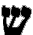 The sensitive principle, the flesh, eternal life.
Hieroglyph, the FOOL. A man in the garb of a fool, wandering without aim, burdened with a wallet, which is doubtless full of his follies and vices; his disordered clothes discover his shame; he is being bitten by a tiger and does not know how to escape or defend himself.
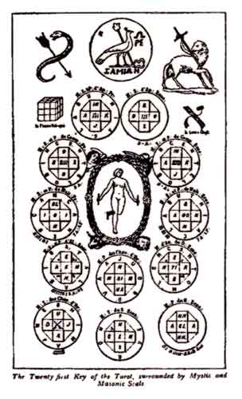  See Note 3 | The microcosm, the sum of all in all.  Hieroglyph, KETHER, or the Kabalistic Crown, between four mysterious animals. In the middle of the Crown is Truth holding a rod in each hand.  Occult medicine is simply the exercise of the will applied to the  very source of life, to that Astral Light the existence of which is a fact, which has  a movement conformed to calculations having the Great Magical Arcanum for  their ascending and scale. This Universal Arcanum, the final and eternal secret of  transcendent initiation, is represented in the Tarot by a naked girl, who touches  the earth only by one foot, has a magnetic rod in each hand, and seems to be running  in a crown held up by an angel, an eagle, a bull and a lion. Fundamentally,  the figure is analogous to the cherub of Jekeskiel, of which a representation is  given, and to the Indian symbol of ADDA-NARI, which again is analogous to the  ADONAI of Jekeskiel, who is vulgarly called Ezekiel. The comprehension of this  figure is the key of all occult sciences. -- I, XXII  The twenty-second Key, which bears the number twenty-one because the fool which precedes it carries no numeral, represents a youthful female divinity, veiled slightly and running in a flowering circle, supported at four corners by the four beasts of the Kabalah. In the Italian Tarot this divinity has a rod in either hand; in the Besançon Tarot, the two wands are in one hand while the other is placed upon her thigh, both equally remarkable symbols of magnetic action, either alternate in its polarization or simultaneous by opposition and transmission. -- Vol. II, Ch. XII.)
Note 1: The Juggler (Le Bataleur) is taken from a Russian edition of Levi's History of Magic. However the caption attributes this figure to another work of Levi's, Cles Majeures et clavicules de Salomon. If you can trace this image to its origin and send me a better scan, please do.
Note 2: "The Tenth Key of Tarot" is taken from the book by Eliphas Levi, La Clef des grands mysteres.
Note 3: "The Twenty first Key of the Tarot surrounded by Mystic and Masonic Seals" is taken from a Russian edition of Levi's History of Magic. Click on the image or here to see the enlarged picture of the Tarot Key itself.

