Hi All,
93
I've appended the Editorial on our A.'.A.'. page to include the following (below).
Enjoy!
93/93
pj

On the Problem of Intellectual Property in Thelema—Comments on: Rethinking Intellectual Property: History, Theory & Economics by Stephan Kinsella of the Ludwig von Mises Institute

Do what thou wilt shall be the whole of the Law.

Anyone who participates in the world of ideas and the generation of human letters strives to share those ideas and find the occupation of this as an ideal career option. And in a small community, such as the Thelemic community, profitability on publication or the demand for professorship is quite limited if not wholly nonexistent; right from the outset. The ideas themselves may be the product of the more noble strivings of the human soul in the greater quest for virtue in life, but their importance to human evolution has become all too obscure in our contemporary, materialist and consumer-oriented society. Stephen Kinsella’s observations on the libertarian movement that developed from Renaissance thought and leading to the American Revolution have a profound bearing on the Thelemic and larger Occult movement today.
That ideas can be owned is a sever restriction on the development of human knowledge; a restraint against the will of society; individually and collectively. If I can’t use ideas readily available to me in order to contribute to and develop those ideas without first having to pay a fee or royalty, one of the worst forms of restriction is at play—censorship.

In previous decades libertarians viewed intellectual property as a boring and technical area of the law, the province of legal specialists. They also assumed it to be a legitimate, if arcane, type of property in a capitalist, free-market society. After all, it's in the Constitution, and Ayn Rand blessed it. But we don't ignore it anymore, and we don't take its legitimacy for granted. We can't. The injustices of IP have multiplied in the Internet age and are staring us in the face.
The advent of the Internet, digital information, and easy file-sharing and duplication have been met with ever-more draconian enforcement of the state's IP law, and with incessant lobbying for legislation to make IP stronger and last longer. Just as the state wants to tax everything that moves, intellectual properteers want to cover ever-more subjects of life with IP protection. But everyone — the young, students, and libertarians — copies files, and we all regularly hear stories about insane patent and copyright lawsuits. Single moms and college students are sued for file-sharing. The IP barons seek three-strikes-and-you're-out laws banishing accused offenders from the Internet for life. They seek international enforcement of their national monopoly rights, to harass street vendors in third-world countries. The legislators, who are in their pockets, have already outlawed the possession of devices that might be used to crack encryption codes. Their propaganda — in TV commercials, video games, magazine ads, and unskippable warnings at the beginning of DVD movies — hectors kids and college students about how uncool it is to copy.

By way of examples from our own experience, in two specific incidents, we are prevented from publishing on the web, two works, one by Crowley and Motta, and one by Motta alone (and that we ourselves have commented upon). These two men are dead, but have had their legacy victimized by organizations that have a legal hold on these documents and are engaged in thwarting the will of the two authors as much as restricting the flow of Gnosis to publication.

We hear regularly about multimillion- or even billion-dollar patent lawsuits, and about the millions of dollars spent by corporations on patent attorneys and litigators just to cross-license with each other, leaving smaller companies outside the walls of the barriers to entry erected on these patent arsenals. In the name of IP, books are banned, movies are ordered destroyed, singers are prevented from singing, car owners prevented from photographing their own cars, churches are prohibited from having Super Bowl parties, and imports of watches and reimports of drugs are blocked. And a little mouse keeps getting his life extended, thanks to copyright — from the original 14 years to over 100. Trumped-up charges of IP infringement are used as an excuse by the government to investigate political opponents. IP may still be arcane, but it's not boring anymore. Scary and outrageous, maybe, but not boring.

In the hypothetical, let’s say that I’ve evoked a certain, well-known spirit that then speaks prophecy of an import for the entire human race. But I refuse to allow the publication of the prophecy without first exacting a fee from my readers. One of them pays the fee, but then publishes that prophecy on the Internet. Do I really have the right to stop this? Do I own these words from this spirit? In actuality, I became the original censor with the claim to property right for this communication. And what the spirit freely gave me, I then coveted; by placing an artificial value upon it.

And should this be any surprise? Copyright is rooted in censorship. No wonder it still leads to censorship today. Patent law finds its origins in mercantilist monopoly grants, and even legalized plunder — letters patent were used to legalize piracy in the 16th century — making it ironic for IP to be used against modern-day "pirates" who are not real pirates at all.
Once IP is seen this way, the scales fall from one's eyes. It's a transformative moment in one's libertarian life, akin to the moment when one finally admits to himself that even the minimal state is criminal and thus adopts anarchism. Realizing that IP is not part of a free-market order makes possible a reassessment of aspects of libertarianism, economics, or social thought hitherto neglected or seen confusingly through the IP haze.

We have become conditioned into a mercantilist culture that is more popularly known as the military-industrial complex with a government seen to engage in corporate socialism. Living within such a system has fostered a conditioning onto our minds that can limit what we see; not unlike religious conditioning.

The history of IP is illuminating. For example, it was not simply invented by infallible, well-intentioned, protolibertarian framers of the Constitution, but originated in censorship and mercantilism. Seen in this light, IP is seen as another mercantilist-corporatist state intervention in the free market. And one simply must have a sound, coherent, and libertarian understanding of property rights, the nature of homesteading, and the nature of contractual exchange, to understand the IP issue. Or, rather, in wrapping your head around IP, you hone and deepen your understanding of property rights, and make new connections. In so doing, new insights become possible, indeed inevitable.

Indeed, one of the most important spiritual practices is to get around taboo; that which is conditioned into us and of which we may even be unconscious. One way to do this is to rethink why one publishes. Does one publish to bring recognition to oneself? Or is one more concerned with the ideas that one has generated; seeking intercourse with other idea generators? The former is more a parasite; a shut-up, more interested in mundane rewards, with the latter being a creator interested in the ideas themselves.

Love is the law, love under will.

Hi PJ
93
I really enjoyed this article and agree with all of the points accept for the last one. I think there is a third alternative between the extreme of publishing only for personal recognition and publishing for the sake of contributing to society. Some people, hmm... such as myself want to contribute to society and be recognized for it. When I produce a product as a contribution to society I take pride in having produced that product and this pride is part of that joy and love which drives the creative process.

I agree that we shouldn't be attached to our work and that we should take joy in seeing our ideas being used, yet in academic circles we are expected to cite our sources for two main reasons: 1, respect for the those who contributed those ideas, 2) for purposes of research and cross referencing. If I don't cite my sources it is very difficult for other creators or thinkers to explore these sources and examine my claims or to even use that same information for another purpose.

Personally the idea of contributing only for contributing sake is unbalanced and runs along collectivist lines since where the individual is expected to give himself up to the 'common good'. We have all seen the results of societies that don't reward the individual for their efforts... they become stagnant and their more brilliant citizens move somewhere else where they will be able to get recognition for their work. (this is why people intelligent people flee from communist countries)

Having said this I agree that intellectual property is problematic, for the same reasons cited in your article; however I also think that taking another persons ideas without given them recognition for their contribution is also wrong, at least for someone like me who enjoys having a ego.
93/93
Ryan

Hi Ryan,
93
Certainly, I'm not arguing against intellectual and scholarly standards. There's everything right about giving recognition to the creators and originators. The question is the idea itself; does that deserve to be withheld until money is exchanged? What good would that be doing, if I couldn't use your idea to build upon and develop that idea?
Regarding creative ideas, such as a novel or a piece of music; does it even make sense to try and copyright it? As soon as it's in digital format, it can be easily copied by everyone. Even record companies today, have all but given up on the hope of collecting royalties. As soon as your novel is published, I can read it for free...someone will get it online.
By turning ideas into a product, we diminish the quality and value of the ideas. If your novel is meaningful, then you would want people to read it. You may sell your books, and plenty of people (assuming a strong novel) will buy the book; the book itself (bound paper and words) being the product that can be owned and not the ideas that those words illustrate.
It is only in modern times that copyrights have been created and then ultimately extended to last long past the time the creator can even hope to live. In other words, it turns his or her descendents into second handers (parasites) as they live off the scarcity created by withholding the IP.
Today, we see the Caliphate (an organization that has almost made it seem glorious to be a parasite) living off the small income they can generate by withholding some of Crowley's ideas from the public. And with bugs like this in control of some of Crowley's catalogue, we can be thankful that he didn't copyright most of his material...or he might not even be an historical footnote today.
In my editorial, I'm not talking about some sort of collectivist/socialist ideal; I have no interest in promoting this sort of thought. Rather, I'm showing that on its opposite end, market fundamentalism doesn't work either. Everything doesn't have to be put into a packaged product...the nobility of humanity requires the infusion of profound ideas that can't be packaged. This doesn't mean that the college professor can't be paid for publishing in professional journals and that the novelist can't receive a royalty on his or her latest novel after it goes into print.
So let's take a real example; Crowley translates the I-Ching and comments upon it (the I-Ching not being copywritten; i.e. in the public domain); Motta (before the Caliphate is formed) takes this translation and appends his own commentary. I come along and append my comments to these and publish it on my website. The Caliphate contacts my web provider and shuts down my website; forcing me to remove this document before I can return my site to the web. I sign an affidavit asserting that I will not publish Crowley's translation of the I-Ching to assure my web provider that they won't have any further legal liability for my behavior.
Both Motta's ideas and mine are now deprived to the public and someone that might have made use of those ideas to assert yet more ideas will not have the access to the original ideas that would have come his or her way. I've noticed that the Caliphate has let another lodge publish the work online...so they've been given the power to restrict my will and yet assert the will of their chosen and preferred. So much for the word of sin.
And if I had published 10,000 copies of my commentary, I wouldn't be able to sell the ink and paper that is my actual property because of the nebulous and abstract idea of intellectual property. Now, back to your novel...let's say you published and sold 10,000 copies of your novel. As this then would be an established fact, let's say I come along and re-publish your novel; have I robbed you of your ideas? Of your physical property? NO. Of course, had your novel become popular, I probably wouldn't really get the time to publish your novel as the original would be in active and constant production and more than likely, other distributors wouldn't take the risk of flooding the market to their own loss. They'd be more interested in a competing novel to get people's attention. And the same loss would befall me should your novel not be popular...or maybe, my publication will make your novel popular when it would not have been. Then all the lecture tours that were not coming your way, are now coming your way, et al ... and you're earning money on your own labor and not the labor of others that have chosen to manufacture new copies of your novel that you'd never have to work again.
And finally, to reply with a question: After you've written your novel, how long should you be allowed to withhold that novel from the public before exacting a fee for the reader to take in those ideas? How many school rooms will not be allowed to talk about your novel without paying you a fee?
Today, they have to wait 150 years; the normal length of a copyright.
93/93
pj

93 Paul.
I agree completely with ALL of the statements within your article. It truly is unfortunate that the c.O.T.O., because of having legal rights to these published documents, are withholding, and blatantly going against what Thelema really is. "The word of sin is restriction".
It is preventing others from finding this commented on material and using it because it is useful and expounded upon.
I really think it is not so much a deal of plagiarism... Everyone expounds and learns from others original work. Continuing with this lineage of Gnosis so to speak, is the only way to keep the information fresh and alive.
As for Ryan's remark on Ego... It is good to use ego, to an extent, but not to let it use you. One of the main aims of the Great Work is annihilation of ego. This, is of course after...Much after the first primary aim, which is K.&C. with ones H.G.A.
I am not arguing your point...As, many do love Ego. When ego is gotten away from, then one may easily be able to understand more easily Paul's point in his article.
Thanks for the article Paul...I found it most beneficial.
93 93/93.'.
James

Hi James,
93

I agree completely with ALL of the statements within your article. It truly is unfortunate that the c.O.T.O., because of having legal rights to these published documents, are withholding, and blatantly going against what Thelema really is. "The word of sin is restriction".
It is preventing others from finding this commented on material and using it because it is useful and expounded upon.
I really think it is not so much a deal of plagiarism... Everyone expounds and learns from others original work. Continuing with this lineage of Gnosis so to speak, is the only way to keep the information fresh and alive.
Yes, there is no plagiarism in using someone else's ideas as a springboard for one's own ideas. And beyond this, ideas, like the air, can't be owned...but must be breathed by all.
As for Ryan's remark on Ego... It is good to use ego, to an extent, but not to let it use you. One of the main aims of the Great Work is annihilation of ego. This, is of course after...Much after the first primary aim, which is K.&C. with ones H.G.A.
In the past, we've spoken a good bit on this list about what we've called the ego-loser philosophy. The Tiphareth experience (H.G.A.) is not about losing the ego; a distortion perpetuated by a group of non-spiritual people that took over the Caliphate and extolled their ignorance quite loudly. The Tiphareth experience is about putting the higher ego on the throne of the Soul. The Abyss experience is an ego-transcendent experience...one can't lose one's ego and one's ego doesn't want to be lost and can't decide to become lost. If you lost your ego, you wouldn't know who you were to get out of bed in the morning.
I am not arguing your point...As, many do love Ego. When ego is gotten away from, then one may easily be able to understand more easily Paul's point in his article.
I'll again disagree here...one without an ego won't be available to understand...there would be no one to experience the joy of understanding.
The editorial isn't about losing one's ego when one produces an original and creative work...it's about the world of ideas being unquantifiable; hence, incapable of being held as a scarce resource upon which a value can be found in the marketplace. Such action is an alienation of the idea. Rather, it's about having the pride (an act of Hadit...ego) to put one's ideas out for others to take in. Remember, ego and pride go well together:
AL I.61: "But to love me is better than all things: if under the night-stars in the desert thou presently burnest mine incense before me, invoking me with a pure heart, and the Serpent flame therein, thou shalt come a little to lie in my bosom. For one kiss wilt thou then be willing to give all; but whoso gives one particle of dust shall lose all in that hour. Ye shall gather goods and store of women and spices; ye shall wear rich jewels; ye shall exceed the nations of the earth in splendour & pride; but always in the love of me, and so shall ye come to my joy. I charge you earnestly to come before me in a single robe, and covered with a rich headdress. I love you! I yearn to you! Pale or purple, veiled or voluptuous, I who am all pleasure and purple, and drunkenness of the innermost sense, desire you. Put on the wings, and arouse the coiled splendour within you: come unto me!"
93/93
pj

Do what thou wilt shall be the whole of the Law.
In regard to Ego, which I still feel that it is useful, at times. Of course one cannot be fully without "Ego".
Perhaps this will shed some L.V.X. on the subject of "Ego" in which I am speaking of:
I:3 The center is everywhere, the circumference nowhere; that "Every man and every woman is a star", a "Khabs," the name of the house of
I;41 Hadit; that "The word of Sin is Restriction". To us then, "evil" is a relative term; it is "that which hinders one from fulfilling his true Will."
The Osirian Rituals, inculcating self-sacrifice to an abstract ideal, mutilation to appease an ex cathedra morality, fidelity to a` priori formulae, etc., teach false and futile methods of acquiring false Knowledge; they must be "cast away" or " purged". The schools of initiation must be reformed.
The analogy is precise; Therefore when one becomes the "knower", , it involves the "death" of all sense of the Ego.
The Aspirant must well understand that it is no paradox to say that the annihilation of the Ego in the Abyss is the condition of emancipating oneself, and exalting it to unimaginable heights, so long as one remains one's self, one is overwhelmed by the Universe; destroy the sense of self, and every event is equally an expression of one's Will, since its occurrence is the resultant of the concourse of the forces one recognizes as one's own.
II:9 Remember all ye that existence is pure joy; that all the sorrows are but shadows; they pass and are done; but there is that which remains.
I am also well aware that annihilation of Ego doesn't occur in Tiphareth. It actually can occur within any path of ones choice...at any time, any place.
AL I.61: "But to love me is better than all things: if under the night-stars in the desert thou presently burnest mine incense before me, invoking me with a pure heart, and the Serpent flame therein, thou shalt come a little to lie in my bosom. For one kiss wilt thou then be willing to give all; but whoso gives one particle of dust shall lose all in that hour. Ye shall gather goods and store of women and spices; ye shall wear rich jewels; ye shall exceed the nations of the earth in splendour & pride; but always in the love of me, and so shall ye come to my joy. I charge you earnestly to come before me in a single robe, and covered with a rich headdress. I love you! I yearn to you! Pale or purple, veiled or voluptuous, I who am all pleasure and purple, and drunkenness of the innermost sense, desire you. Put on the wings, and arouse the coiled splendour within you: come unto me!"
I think in this passage we must remember that this is good. But let us not forget "but always in the love of me, and so shall ye come to my joy.
Tiphareth, upon the tree is part of the process, as it is the "Christing Point" if you will, of one's self. It is the realization of the Crucifixion, or formulae of that of the Dying God. Being Re-born, and is a reflection of Kether. So, I do see it having it's correct correlation with the beginning of the realization of ones Ego, and the eventual, but inevitable letting go of the programmed Ego and old Aeon beliefs and stepping into the new, through working with the ego.(Not letting the Ego work you:-) To attain to the K&C of ones H.G.A.
Again, just my two pennies worth.
Love is the law, love under will.
James
Hi James,
93
I like how you ended your post; "...through working with the ego.(Not letting the Ego work you:-)"--quite profound. Understanding (pun) the utility of the ego for one functioning as an individual star in a fabric of stars so intimately; from every cell in the body to the heights that our intellect and imagination can take us to serves its own purpose of joy. And then to have that unique vantage point of the augoieades that transcends the self; dethroning the myriad complex of petty egos to serve a 'higher self' (greater ego; as if a divine angel) that takes in the totality (the ALL) is the mark of the Great Work in the Outer College.
The talk of losing one's ego is crapulous 'New Age' dogma that has washed into Thelema along with a lot of other superstitious nonsense. Even after the experience of the Abyss, it is said that one's Star is both simultaneously cast into the heavens (the AIN) as one's essence descends back into the Ruach (re-establishing egoic individuality). Nothing is lost nor does anything die; but transformation suits more the recapitulation of this ancienty mystery--this ancient mythos.
93/93
pj

HM Lego of my Eggo?

No seriously overcoming the ego may be nearly impossible, though I do believe controlling it is an option.

regards
johnmoon3717@aol.com

Hi JohnMoon,
93
I've heard it said that with diligence, one might work to squeak a brief momentary peak. But I wonder that that isn't simply due to our evolutionary point. And the question is for us, is that peak repeatable and is it worth the effort? It seems also, as much innate in our species. Some seek this transcendent experience by way of sexual prowess; others are risk takers or gamblers...and there's the adrenaline rush of athletics or being a police or fireman...still others with drugs and others with emotionalism...still others with the intellect and the imagination.
Tom Verlaine said it just right...as a poet of the Punk era: "using words to say what words can't say."
93/93
pj

Hi PJ
93
I think comments in red are useful here...

Certainly, I'm not arguing against intellectual and scholarly standards. There's everything right about giving recognition to the creators and originators. The question is the idea itself; does that deserve to be withheld until money is exchanged? What good would that be doing, if I couldn't use your idea to build upon and develop that idea?
Yes this is the point that I was agreeing with. At the same time where do we draw the legal lines. All books aside, I am designing an online English course with a partner, now if he takes my lessons that I design and sells them without my consent he is breaking our agreement, but he is also stealing my work. Now the issue is this: can I protect myself without invoking 'intellectual property'?

The answer is yes, since it is our contractual agreement that should protect me. And the real issue is the course that I've built rather than the information itself.

But what about inventions? While I see the merit in getting rid of intellectual property we still need to consider how inventors can protect themselves and ensure a fair slice of the pie.
Regarding creative ideas, such as a novel or a piece, of music; does it even make sense to try and copyright it? As soon as it's in digital format, it can be easily copied by everyone. Even record companies today, have all but given up on the hope of collecting royalties. As soon as your novel is published, I can read it for free...someone will get it online.
By turning ideas into a product, we diminish the quality and value of the ideas. If your novel is meaningful, then you would want people to read it. You may sell your books, and plenty of people (assuming a strong novel) will buy the book; the book itself (bound paper and words) being the product that can be owned and not the ideas that those words illustrate.
It is only in modern times that copyrights have been created and then ultimately extended to last long past the time the creator can even hope to live. In other words, it turns his or her descendents into second handers (parasites) as they live off the scarcity created by withholding the IP.
Today, we see the Caliphate (an organization that has almost made it seem glorious to be a parasite) living off the small income they can generate by withholding some of Crowley's ideas from the public. And with bugs like this in control of some of Crowley's catalogue, we can be thankful that he didn't copyright most of his material...or he might not even be an historical footnote today.
In my editorial, I'm not talking about some sort of collectivist/socialist ideal; I have no interest in promoting this sort of thought. Rather, I'm showing that on its opposite end, market fundamentalism doesn't work either. Everything doesn't have to be put into a packaged product...the nobility of humanity requires the infusion of profound ideas that can't be packaged. This doesn't mean that the college professor can't be paid for publishing in professional journals and that the novelist can't receive a royalty on his or her latest novel after it goes into print.
So let's take a real example; Crowley translates the I-Ching and comments upon it (the I-Ching not being copywritten; i.e. in the public domain); Motta (before the Caliphate is formed) takes this translation and appends his own commentary. I come along and append my comments to these and publish it on my website. The Caliphate contacts my web provider and shuts down my website; forcing me to remove this document before I can return my site to the web. I sign an affidavit asserting that I will not publish Crowley's translation of the I-Ching to assure my web provider that they won't have any further legal liability for my behavior.
Both Motta's ideas and mine are now deprived to the public and someone that might have made use of those ideas to assert yet more ideas will not have the access to the original ideas that would have come his or her way. I've noticed that the Caliphate has let another lodge publish the work online...so they've been given the power to restrict my will and yet assert the will of their chosen and preferred. So much for the word of sin.
And if I had published 10,000 copies of my commentary, I wouldn't be able to sell the ink and paper that is my actual property because of the nebulous and abstract idea of intellectual property. Now, back to your novel...let's say you published and sold 10,000 copies of your novel. As this then would be an established fact, let's say I come along and re-publish your novel; have I robbed you of your ideas? Of your physical property? NO. Of course, had your novel become popular, I probably wouldn't really get the time to publish your novel as the original would be in active and constant production and more than likely, other distributors wouldn't take the risk of flooding the market to their own loss. They'd be more interested in a competing novel to get people's attention. And the same loss would befall me should your novel not be popular...or maybe, my publication will make your novel popular when it would not have been. Then all the lecture tours that were not coming your way, are now coming your way, et al ... and you're earning money on your own labor and not the labor of others that have chosen to manufacture new copies of your novel that you'd never have to work again.
And finally, to reply with a question: After you've written your novel, how long should you be allowed to withhold that novel from the public before exacting a fee for the reader to take in those ideas? How many school rooms will not be allowed to talk about your novel without paying you a fee?
Today, they have to wait 150 years; the normal length of a copyright.
I have nothing else really to add here since I agree with all of these other points for the most part. However we still need to deal with the issues of inventions and technology and material incentive for the inventors. If there is no way to ensure that one's intellectual work will sustain one'self then only a few rich people will be able to afford to make inventions, which would have to be motivated by altruistic motives or a desire for fame. Otherwise people who need to earn a living wont share or contribute their ideas and we are back again to the same old problem, knowledge being withheld.. Most progress is at least partially fueled by material incentive, especially in todays social demands for a technocratic and expensive lifestyle.

There must be a way of reaching a middle ground on this issue, though at the moment it is late and this brain is getting foggy.
93/93
Ryan

Hi Ryan,
93
I think comments in red are useful here...
I'll respond in green...

Certainly, I'm not arguing against intellectual and scholarly standards. There's everything right about giving recognition to the creators and originators. The question is the idea itself; does that deserve to be withheld until money is exchanged? What good would that be doing, if I couldn't use your idea to build upon and develop that idea?
Yes this is the point that I was agreeing with. At the same time where do we draw the legal lines. All books aside, I am designing an online English course with a partner, now if he takes my lessons that I design and sells them without my consent he is breaking our agreement, but he is also stealing my work. Now the issue is this: can I protect myself without invoking 'intellectual property'?
For one thing, you seem to be ignorning other important considerations. More than just putting together an identical teaching method (for which you, yourself, probably can't really claim to be all that original), this partner would have to generate the materials to reproduce, the capital for such and the capital to promote his program. Now, on the flipside, let's say you develop this idea and you have no funding nor any contacts to help you get that funding. Your idea, the teaching method, would be withheld from doing any good in society. Without IP, I could come along and make that investment and you may be able to piggy-back on my success to get your own program funded.
Let's assume that instead, your program goes well funded and is quite successful and I then create an identical program to compete with you. This would put us both to work at producing both a better program and a more efficient managing office. Society again benefits. With IP, that competition becomes more difficult to implement. Yes, I could make a 'similar' program; but that's really what it would be any way. Don't we see copy-cat businesses all the time? And in this second scenario, you succeeded first...but in both, we both succeeded. With a strict enforcement of IP, considering all its implications, this might be made impossible.

The answer is yes, since it is our contractual agreement that should protect me. And the real issue is the course that I've built rather than the information itself.
The net effect of this would be to prohibit only your business partner from competing with you. The rest of the world will still be able to do so.

But what about inventions? While I see the merit in getting rid of intellectual property we still need to consider how inventors can protect themselves and ensure a fair slice of the pie.
A part of inventing is the ability to produce and promote. The argument against IP here would be not that different from the music business. Produce and distribute copies of your invention; let others imitate to compete, but they won't have the original or maybe either they'll improve upon it or put you in a situation where you improve. One invents to produce, not to sit back and collect royalties. Royalties are real money put to virtual products. Why should I produce a recording of Hey Jude and have to pay the Beatles for that? Let them sell their own version.
Today, as soon as you get your first hit, you're not allowed to listen to the radio or anyone else's production of anything so that you can prove in court that you didn't plagiarize someone else's material. Novelists can't read other novelists, et al; ad nauseum (existential pun). What good is that doing for anybody? In Bach's time (1600's ev) if one copied another's music, it was considered a compliment. IP has really turned this around.

I have nothing else really to add here since I agree with all of these other points for the most part. However we still need to deal with the issues of inventions and technology and material incentive for the inventors. If there is no way to ensure that one's intellectual work will sustain one'self then only a few rich people will be able to afford to make inventions, which would have to be motivated by altruistic motives or a desire for fame. Otherwise people who need to earn a living wont share or contribute their ideas and we are back again to the same old problem, knowledge being withheld.. Most progress is at least partially fueled by material incentive, especially in todays social demands for a technocratic and expensive lifestyle.
I'm not in any way, making an altruistic argument..rather one for greater creativity, productivity and competition...especially of ideas. Its the brainstorming of ideas that will bring society to the new mythos; not the withholding of ideas for some profit-motive and a mercantile practice of business fundamentalism.

There must be a way of reaching a middle ground on this issue, though at the moment it is late and this brain is getting foggy.
I don't know that there is ... the market itself is an organic construct that needs to be approached by a practical and not an ideological (the false ideal of social justice) means.
93/93
pj

Hi All,
93
Another thought regarding this...the problem of enforcing copyrights.
First one has to find a copyright violator; so you put out your brilliant work...and somebody in China starts reproducing it...or in India; both without your permission. Or where else? Or who else? Is it possible to spend the time and energy to hunt down violators? Only big companies inside international markets have this hope...making copyright laws only truly effective for them and as a way to take money and opportunity from the rest of us.
In my own personal experience, I've had Kenneth Grant's people demand that I remove the Kenneth Grant books from my website that are also still floating around on the net. So Grant's ideas are finite and can only reach those who find certain quarters. The same goes with the Caliphate and H.O.O.R.; though they got legal right away and are also now still further doomed to have to search my site regularly for any new violations.
My ideas have been translated into Russian and I'm reaching a larger and larger audience all the time; they're available for free and I applaud people who either link to them or put them up on their own site; e.g. an A.'.A.'. lineage in Brazil that has published a Portuguese translation of my transcription of a Motta lecture. Cammy's translated one article into Spanish...and I have no idea if people in these areas are playing with these articles and what they're doing with what started out as my idea and with luck is becoming the seed for ideas generated by other people.
Of course, if my ideas become in any way popular, there will be second handers (parasites) to come along and say that they have brilliant or secret insight into my ideas that they can try to then own my ideas. Doesn't this sort of thing happen all the time?
93/93
pj

93
I think knowing the source of the information is important so we can verify the authenticity or truth of said sources, and know the context.
Also, in the argument from authority the authority must be a legitimate expert on the subject - http://en.wikipedia.org/wiki/Argument_from_authority
93 93
Cammy
Hi Cammy,
93
Yes, ‘appeal to authority’ can be persuasive; though it’s often too persuasive. Often enough, authority figures speak outside of the area of their expertise; their opinions even being expressed for propagandistic purposes. So critical analysis (dianoesis) is still necessary in responding to their oracles. But this all goes to the world of ideas and their generation. Note first that it is on the plane of ideas that man’s intellectual evolution prospers; and that this plane must allow for the free expression of ideas without any censorship. No Shut-Ups should be allowed to practice the dark magick of owning ideas. This is a-priori, counter-evolutionary behavior that delimits growth and crushes the seeds of growth. Ideas have their vegetative expression; just because someone is the first to generate an idea, that doesn’t mean there isn’t (and actually, there always have been) somebody also working along those lines. We can substantiate this through observed behavior as used in the morphogenetic field theory; e.g., the monkey on one side of the island, washing his potato before eating it…and synchronistically, the monkeys on the other side of the island doing the same.
93/93
pj
HM if you are seeking Gnosis,,,,,,?The only authority you need appeal to is your own.If your seeking Knowlege? Perhaps John Moon
Hi JohnMoon (new name?...Moon John…Little John…Big Bad John…lol),
93
Opinions generated by others of Gnosis enlarge our experience and inspire further creativity. The Gnosis doesn’t give everyone the same viewpoint; we each having our own unique coordinates in the Universe. So we gain from the sharing of our perspectives and this is the dialogue that creates our society. After all, we are also social creatures, by nature. To close ourselves off with the misperception of a single idea or mindset of knowing that is Gnosis can only lead to what is referred to as the ‘lonely towers of the Abyss’ in Thelema. It is an essential failure of cognition; a myopia on the visionary plane, supported by a superstitious narcissism on the emotional plane. Spiritually, it’s a closing of the heart; substituting this idea of an absolute truth.
93/93
pj

I think one needs to be careful to separate,Gnosis,,,,,,,,,where your internal gnosis may reveal the truth
and Knowledge where you appeal to authority from others and books.and learn opinion and facts.
and finally wisdom
which is the discernment to use the knowledge within the confines of your own gnosis

after all , there is a significant amount of appeal to authority of the egyptian Gods, and Greek,persian and others now long forgotten
The MAyans and Incas appealed to authority when they sacrificed people on their pyramids.One has to be cautious.
And where in truth this may stimulate the seeking of greater knowledge?
That knowledge( Appeal to authority)May in fact be wrong.

that is where wisdom comes in....To discern the difference

IMHO
regards
johnmoon3717@aol.com
Hi JohnMoon,
93

I think one needs to be careful to separate,Gnosis,,,,,,,,,where your internal gnosis may reveal the truth
and Knowledge where you appeal to authority from others and books.and learn opinion and facts.
and finally wisdom
which is the discernment to use the knowledge within the confines of your own gnosis
I don’t really see this separation; wisdom comes from experience—applied Gnosis; knowledge and Gnosis are the same words in different languages—specifically, Gnosis carries the idea of a spiritual knowledge…but what isn’t spiritual? And for internal truth…well, truth is a key to the nature of human development in the Piscean Age and while there is an internal truth, that’s really not the same for each of us…so I wax a bit Platonic here when I claim this internal truth to be a correct opinion for the self; based on one’s individuality. But I also recognize the truth of others though different, should append mine and not really contradict it. Yet I wouldn’t claim such inner truth to have an absolute appeal; except for that non-individuated spark of God that is in each, our heart of hearts.

after all , there is a significant amount of appeal to authority of the egyptian Gods, and Greek,persian and others now long forgotten
I think a superstitious culture appeals to mythological pantheons for anything whatsoever. In the practice of Magick, these myths inform us how to apply certain aggregates of wisdom (another word for Magick) in order to inform our own being and enhance or evolve our individual natures. But once we start quoting this or that God in argumentative appeal to authority, we are no better than the southern televangelist who alleges to hear God’s word and claims authority to take our money.

The MAyans and Incas appealed to authority when they sacrificed people on their pyramids.One has to be cautious.
Yes, another superstitious culture…I can hear my sixth grade English teacher: “If everyone else was jumping off a bridge, would you also?”

And where in truth this may stimulate the seeking of greater knowledge?
I’m not sure of your question and/or rhetorical question…but certainly myths provide us a way to look into and better understand ourselves and our relation to the world around us. And of course, the old myths appealed to an old and long-gone world. This is why some of us in Thelema are weeding out a new myth from the ashes of the old. I’m referring to my Enochian work and of course, Crowley’s skrying of those aethyrs into the mythos of Babalon and the Beast; taking from the prophecy of the Christian ethos and bringing it to the post-industrial mind.

That knowledge( Appeal to authority)May in fact be wrong.
That was precisely the point I was trying to make in my reply to Cammy. But I only took it from one angle; the expert opining outside the field of his or her expertise (and usually to propagandistic ends). But indeed, though an expert, there are many times such can and often are wrong. One example of this is working within an incorrect theoretical paradigm from incorrect assumptions. This is often the case in academics; where an old wave of Ph.Ds hold up an established order. Hell, it’s not that much more than 100 years ago, doctors were still bleeding humors to get rid of the evil spirits that cause disease.

that is where wisdom comes in....To discern the difference
And discernment takes practice, which well comes from dialogue and debate.
93/93
pj

93
My problem with plagiarizing is that someone can take ONE idea from another, then 'muddy the waters' and add other bits and pieces (cherry-picking) until the original is totally unrecognizable. And is it even worthwhile?
There are a number of corrupt people - politically and spiritually - who have used others' gnosis for their own gain, and go against the original intention or application. So even a concept that had nothing to do with, say, a corrupt leader later on, but which the leader used in his philosophy, becomes suspect.
If there's anything to learn from this is that there is more contrast, and seekers are able to find true gnosis.
93 93
Cammy
Cammy, John & Pj
93
The hypocrite king doesn't wear a crown and cannot wield his sword. Or in other words; the proof is in the pudding.

93/93
David
Hi Cammy,
93
I wouldn’t call that plagiarizing; but brainstorming and the creative process. The new product is derived from the old and we end up with 2 new products; based on your description. Plagiarizing is when one takes another’s words (say a news article written by the local reporter) and claims them as one’s original thought. That raises questions of credulity and competence; but that is all.
Regarding those who would come to spirituality with only political intent; common enough in all spiritual and religious institutions, this type of person will always be amongst us. And there will always be those that are duped by these types. Sometimes, this doesn’t betray so much a lack of intelligent, but a victimization by way of a con. It is important to understand how to properly respond to these type of people when we find them amongst us.
Though I had no personal regard for Isaac Bonewits, I have always respected his points on how to recognize a cult, which type of person in positions of spiritual and religious leadership often formulates:
1 Internal Control: Amount of internal political and social power exercised by leader(s) over members; lack of clearly defined organizational rights for members. 1_____________________________
2 External Control: Amount of external political and social influence desired or obtained; emphasis on directing members’ external political and social behavior. 2_____________________________
3 Wisdom/Knowledge Claimed: by leader(s); amount of infallibility declared or implied about decisions or doctrinal/scriptural interpretations; number of degrees of unverified and/or unverifiable credentials. 3_____________________________
4 Wisdom/Knowledge Credited: to leader(s) by members; amount of trust in decisions or doctrinal/scriptural interpretations made by leader(s); amount of hostility by members towards internal or external critics and/or towards verification efforts. 4_____________________________
5 Dogma: Rigidity of reality concepts taught; amount of doctrinal inflexibility or “fundamentalism”; hostility towards relativism and situationalism. 5_____________________________
6 Recruiting: Emphasis put on attracting new members; amount of proselytizing; requirement for all members to bring in new ones. 6_____________________________
7 Front Groups: Number of subsidiary groups using different names from that of main group, especially when connections are hidden. 7_____________________________
8 Wealth: Amount of money and/or property desired or obtained by group; emphasis on members’ donations; economic lifestyle of leader(s) compared to ordinary members. 8_____________________________
9 Sexual Manipulation: of members by leader(s) of non-tantric groups; amount of control exercised over sexuality of members in terms of sexual orientation, behavior, and/or choice of partners. 9_____________________________
10 Sexual Favoritism: Advancement or preferential treatment dependent upon sexual activity with the leader(s) of non-tantric groups. 10_____________________________
11 Censorship: Amount of control over members’ access to outside opinions on group, its doctrines or leader(s). 11_____________________________
12 Isolation: Amount of effort to keep members from communicating with non-members, including family, friends and lovers. 12_____________________________
13 Dropout Control: Intensity of efforts directed at preventing or returning dropouts. 13_____________________________
14 Violence: Amount of approval when used by or for the group, its doctrines or leader(s). 14_____________________________
15 Paranoia: Amount of fear concerning real or imagined enemies; exaggeration of perceived power of opponents; prevalence of conspiracy theories. 15_____________________________
16 Grimness: Amount of disapproval concerning jokes about the group, its doctrines or its leader(s). 16_____________________________
17 Surrender of Will: Amount of emphasis on members not having to be responsible for personal decisions; degree of individual disempowerment created by the group, its doctrines or its leader(s). 17_____________________________
18 Hypocrisy: Amount of approval for other actions which the group officially considers immoral or unethical, when done by or for the group, its doctrines or leader(s); willingness to violate group’s declared principles for political, psychological, economic, military, or other gain. 18_____________________________
Per “true” Gnosis…this is a murky phrase. What is true Gnosis? Is it really the same for you and me? This is what I was trying to point out to JohnMoon. If there is no “true” Gnosis, then life becomes much more interesting. I can discover and dialogue on your experience of this and can gain by using that to better understand my own assessment of Gnosis within myself. This makes our interaction interesting and keeps the experience of Gnosis on its own evolutionary path.
As each generation must redefine its relationship with the divine, so Gnosis is different for the 16th Century ev monk than it would be for the 21st century ev monk. If we were to freeze upon it a definition that is permanent and eternal, we mimic the ego, which itself is under that constant delusion that nothing ever changes; and hence we become perfect fodder for duping by the Black Lodge.
This, Christianity has done as most major world religions. The “truth” is known and there is nothing new to explore. It makes it easy to understand how a museum can be built in Texas that demonstrates the world is only 6,000 years old…and all the fanatical wars in the name of God. How boring!
It’s far more enlivening to participate in the dynamic of change; the one constant in the Universe. The Gnosticism that preceded Christianity was highly creative and constantly evolving; until Caesar and Irenaeus froze it. We’ve had about 1700 years of their Dark Ages mentality in our European culture.
The old documents shed light on the original creativity…and new things today, such as the Philosophy of Thelema show that spark alive again, in some of us.
But all in all, the individual Gnosis in all intelligent people fascinates me…each has their own perspective. And sometimes, I’ll disagree, as it doesn’t seem to match anything I understand…as others will do with what I report.
93/93
pj
Hi Guys,
93
During the Baroque era in Europe, composers who “stole” (in today’s terms) lines from other composers were considered to have paid a compliment. Today, under the banner of IP, this earns the composer a lawsuit. I hated when George Harrison was sued (I can’t remember the song: My Sweet Lord or Here Comes the Sun—I think) … and today, a contracted musician is not allowed to listen to the radio or attend concerts. He or she has to be able to prove that they couldn’t possibly have heard a certain song; should they be dragged into court for a copyright dispute.
Now…how does that promote the creative process? It doesn’t and it actually impedes it.
IP is an assault on creative culture.
93/93
pj
Speaking of authority figures speaking outside the area of their expertise....
http://homebrewedtheology.com/you-wouldnt-call-a-landscaper-to-fix-the-supercollider.php

You Wouldn’t Call A Landscaper To Fix The Supercollider
By Christian On July 5, 2011 · 4 Comments
2tweetsretweet
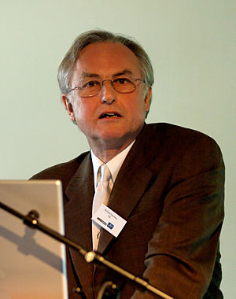
Image via Wikipedia
…so it really makes me think why someone would cite a non-theologian as an expert in theology?
I participate on a liberal discussion board where I’ve been a member since 2001. I post occasionally, pickup news stories from there… nothing too exhaustive.
However, one of the sub-boards is Religion/Theology. It’s more of a battleground than discussion, as there are a number of members who are openly hostile to Religious folks of any stripe, Christians in particular. Despite overwhelming evidence to the contrary, these folks lump all Christians into the “irrational, homophobic, anti-women, afraid of science, want to create a theocracy” category.
I, of course, take exception to that. Yet in any discussion there are two straw-points that these folks are stuck to like chihuahua on a pork chop.
- They demand to know what’s literal and what’s not in scripture.
- If your interpretation doesn’t fit their little box, they immediately protest with “Why is your interpretation the right one?”
On point 1, I’m tired of answering that question and do my best to ignore it because “scholarship” is obviously the wrong answer.
On point 2, I always ask…. “Are you a theologian?” Naturally the immediate response is “Ahhhh…argument from authority!”
Umm… I like to think that as someone who has studied theology and is degreed in theology… I might know a little about that.
Like the title says, you wouldn’t call a landscaper to fix the Supercollider, right? People go to school, study particular subjects, and even work in those fields to become experts.
I’m sure Richard Dawkins is a brilliant biologist, being educated in zoology, but a theologian he is not.
I’m sure Sam Harris is much more brilliant than me in neuroscience, but a theologian he is not.
Same with Christopher Hitchens…. yet these are all people that atheists, in particular, will cite as experts in theology.
Am I wrong in thinking that if you want answers about scriptural interpretation and exegesis, you’d ask a theologian and not a zoologist?
93
Hi Cammy,
93
There is a difference between pop culture and academic culture. And it is in pop culture where the intellectual laity (amateurs that they are!) get to practice their own interest and dabble in theologizing. This doesn’t open the door for the superiority of academic culture. Do I need an advanced degree in theology before I can decide to pursue a spiritual path or to convert to another religion? No!
Academia provides one perspective; a perspective that is often-enough superior to what pop culture can produce. But just sometimes (as we Americans have championed) pop culture also produces great and superior profundity.
Chris Hitchins is a perfect example; though I personally am uninterested in his atheism.
93/93
pj
from http://mysticalseeker.blogspot.com/2007/08/way-sunlight-amuses-itself-on-water.html
"When she says that faith isn't rational--because that's what makes it faith--I would probably phrase that a little differently. I would say instead that faith is not empirical, which is not quite the same thing. I think that religion can be rational (or irrational) in certain ways, but that it deals with a greater level of experience that lies beyond mere empirical knowledge."
Because religion doesn't restrict itself to the immediate experience of objective facts--God, I would argue, is most certainly not an "object" like any other to which objective facts easily apply--I think the most important point that Elizabeth Gilbert makes is that she is not interested in the insurance industry. Faith is not insurance. Those who claim their belief in God is a surefire ticket to an afterlife have bought wholesale into the insurance model. But as Ms. Gilbert points out, faith necessarily entails doubt. The leap of faith into the unknown necessarily involves an unknown. And it is a poetic leap at that. The leap itself is its own reward, because there is no assurance of where the leap will take you."
Elizabeth Gilbert - “I want God to play in my bloodstream the way sunlight amuses itself on the water.”
Here I wouldn't be supporting a leap of faith, which is in other words blind faith, but going with one's intuition. Like why does something resonate so strongly within us for no apparent reason? Why do we have gut-instinct or premonitions? And things of that nature.
93
Cammy
HI Cammy,
93
And so indeed!...how different we are that one thing resonates with one and not another.
So much variety in the Gnosis. To quote an old rock song I wrote years ago:
So many costumes, so many customs
So many ways we can dance
So many people, so many cultures
So many ways to entrance
So many costumes, so many customs
So many reasons to dance
So many people, so many cultures
So many ways to romance
93/93
pj
Alan Watts - To know that you are God (audio with pic):
http://www.youtube.com/watch?v=KL_qMeDv9rA&feature=mfu_in_order&list=UL
93
Cammy
Hi All,
93
To expand on the so-called problem of plagiarism, I would like to quote from Ben Hecht’s Child of the Century, as found in our A.M.H.R. Editorial.
.. that a wise man will always allow a fool to rob him of ideas without yelling, "Thief." If he is wise he has not been impoverished. Nor has the fool been enriched. The thief flatters us by stealing. We flatter him by complaining.
93/93
pj
93
If everyone's personal Gnosis is different, I would still say it should be verified. There is a wall of assumed infallibility when it comes to this, that if one "feels" it's true then it somehow must be; if that is challenged then one's personal wisdom is being violated, lol...the "feel-good" excuse (so does masturbation; like why people pray, petioning a sky-daddy). Using the scientific method, even if it's not just a feel-good sensation but a true aspiration - it would be best to have empirical evidence, but there are many other kinds of evidence and using the argument that one absolutely needs it to be empirical, makes the investigation nearly impossible as it is unfair. We decide on what to believe, and even act upon, things that are based on experience, intuition, or an analysis of chance and risk, a new opportunity. And one may or may not feel optimistic, also affecting the success. But the past failure of the same situation does not predict a new try. Were this so, many of the inventions we have today would not exist.
93 93
Cammy
Hi Cammy,
93
There’s a stage; and interestingly enough I’ve felt for years it occurs at the Grade of Philosophus in the A.’.A.’. (my current Grade!) when one can be duped into believing one has attained. The work of the Philosophus is in Netzach (Venus) with the Sefira being a reflection of Binah (the Grade of Master of the Temple). And I really believe, as I have since I departed from him, that this is the mistake my former instructor, Ray Eales made. Fortunately for me, I see my own foibles all too well to fool myself; and even now, I see Ray’s mistake with all that much more clarity.
One way that the A.’.A.’. proves the veracity of a claim, as I’ve said a couple times before, without the writing of the tome of the Major Adept (6=5) we know the Knowledge & Conversation of the H.G.A. (5=6) was not attained. And without a School of Magick being set up (9=2), we know one has not bridged the gulf of the Abyss (8=3). More than a few regularly come along making these claims and they remain unrecognized by US…yet by the ignorant sycophants that surround them.
Where is my MITP? Where is my Transcendental Magick? Where is my special School of Magick?
Note, these I have not…note, I don’t make any claim of attainment either.
And should I succeed, I won’t so much make the claim…I’ll first publish the book.
AL III.46: "I am the warrior Lord of the Forties: the Eighties cower before me, & are abased. I will bring you to victory & joy: I will be at your arms in battle & ye shall delight to slay. Success is your proof; courage is your armour; go on, go on, in my strength; & ye shall turn not back for any!"
93/93
pj

Hi PJ and Cammy
93
I enjoyed your lyrics PJ and I like what you wrote Cammy in regard to Empirical evidence. If I accept the language gamed (thinking of Wittgenstein here) of Empirical and non Empirical, I would agree that there is another faculty that is shared by all through which religion and of course culture is developed. It is through this faculty that religious experiences and spiritual insights are encountered.
I don't consider this to be a higher faculty, and I don't consider the five senses to be lower faculties. I don't subscribe to the language game in which there is such a dichotomy. I prefer the general Indian analysis that posits 6 senses instead of five. The mind being the sixth sense. I differ from the Indians though in that I don't see any one sense as being better than the other, but unique with it's own strengths and limits. While I accept the six sense theory as an interpretive model, I do not accept it as having a strong objective status.
Rather, from my own mystical experiences of making dharana on the senses, I have come to the conclusion that there is only really one sense, which I would simply call awareness or consciousness. We have simply divided this awareness and selectively put our attention on certain parts of it: i.e. mind, eyes, touch etc. while the other objects of this universal awareness are then unconscious.
We talk with the angels and devils simultaneously while perceiving the furniture in the room, the smell of the flowers, etc. The five senses or six senses are really mental constructs that we use to analyse and conceptualize our experience. Unfortunately we have such a habit of conflating our mental constructions with our awareness that most of the time we are out of touch with our own awareness, living in a rather fractured and limited world.
The whole western thought menu, of rational irrational/ empirical and spiritual is quite absurd. Even John Stuart Mill was able to come close to this realization when he proved that logical (apriori) knowledge is really another form of empirical knowledge (posteriori)

93/93
Ryan
Hi Ryan,
93
I would be very interested in hearing John Stuart Mill’s proof of the non-distinction between a-priori and posteriori knowledge. It would seem to me, to have to ignore the geometric theorems of Pythagorus; along with the higher, intuitional (sixth sense) mind that Pythagorus gleans from this and introduces into his mystery school. See my writings on the Greek Qabalah (A.’.A.’. website).
The Sixth Sense has been so derided in Christist culture, that it is in need of deliberate instruction, which is why the A.’.A.’. devotes effort to that in the Neophyte Grade. And I feel that proof of success in this is ultimately an intimate familiarity with new Gnosis for the Zelator, Practicus and Philosophus who ride the Astral Triad and swim in the Veil of Qesheth. These separate senses (in the Veil) are the fracturing of the L.V.X.; not unlike the way a prism separates out light.
New Gnosis is the intuitive reconstruction of those colors; until such a point becomes reached that the light is then again one.
In my figuring, this seems to require that it happen not just in the mental or astral sphere…but in the physical sphere…and hence, my GCL research and my interest in the teachings of the Mother. But also, it seems I am engaged in that process…and still I make no profound claim. Yet there are those around me with very profound claims and so very little inside them that might need to come out.
One, like Ray pretends to a profound silence…but he is a shut-up.
Speak!...that is the first way that any proof can be established.
93/93
pj

Hi Ryan
93
In Section I of Chapter 2 in Kant’s Critique of Pure Reason, Kant makes the same claim I make to a-priori reasoning relative to geometry and space.
So I’m quite eager for your response, re: John Stuart Mill’s proof that a-priori knowledge is identical to empirical knowledge.
93/93
pj

Hi PJ,

93
To finally answer your question pertaining to Mill, I have put together the following which is an extreme simplification of his defense:

In his system of logic his main controversial thesis is that no real proposition is a-priori thus making both mathematics and logic empirical in his own system.

First point: If logic did not contain real inferences all deductive reasoning would be a begging of the question and would thus produce no new knowledge. (i.e. petitio principii)

Since logic does produce new knowledge, logic must contain real inferences.

This very same premise is also applied to mathematics since it is also required of the same prerequisites in order to produce new knowledge.

So why do we believe real prepositions in mathematics and logic to be a-priori?

Because their negation is inconceivable.

The inconceivability of the negation of certain logical truths naturally demands justification. This justification must itself be apriori if it is to show that the proposition is known a-priori.

One example would be geometrical intuition, normally considered a-priori knowledge. While Mill is said to concede to this intuition; he maintains that the reliability of geometric intuition is only known and demonstrated as an empirical fact.

Thus the validity of the geometric axioms are only demonstrated through the five senses, and is thus known inductively.

To put these premises in more common language we can say that the validity of logic and mathematics is only known and demonstrated through its ability to accurately give us new knowledge that can be verified only by the five senses. Thus this so called a-priori knowledge is both derived and proved through posteriori sources, albeit our five senses.

While I wouldn't go so far as to say that his explanation discounts the other notions of a-priori knowledge, I think these points are valid and indicate the holistic nature of our knowledge processes.

This should satisfy your initial critique:

I would be very interested in hearing John Stuart Mill’s proof of the non-distinction between a-priori and posteriori knowledge. It would seem to me, to have to ignore the geometric theorems of Pythagorus; along with the higher, intuitional (sixth sense) mind that Pythagorus gleans from this and introduces into his mystery school. See my writings on the Greek Qabalah (A.’.A.’. website).

93/93

Ryan
Hi Ryan,
93
I can see the territory you covered in your email and realize how much you had to take out of the argument to be functionally concise.

In his system of logic his main controversial thesis is that no real proposition is a-priori thus making both mathematics and logic empirical in his own system. First point: If logic did not contain real inferences all deductive reasoning would be a begging of the question and would thus produce no new knowledge. (i.e. petitio principii)
This would have to be explained: we infer using a tool called deductive reasoning. Using measures to investigate the inherent nature of the circle are a mathematical contrivance overlayed onto the praxis of deductive reasoning. But there is a difference between the action (verb) and the tool (noun).

One example would be geometrical intuition, normally considered a-priori knowledge. While Mill is said to concede to this intuition; he maintains that the reliability of geometric intuition is only known and demonstrated as an empirical fact.
The empirical demonstration comes about in the display of the tool, which originally applied the logic/math of measure as a way of interpreting that which is inherent in the shape.
93/93
pj

Hi PJ
93

Comments in red.

I can see the territory you covered in your email and realize how much you had to take out of the argument to be functionally concise.

In his system of logic his main controversial thesis is that no real proposition is a-priori thus making both mathematics and logic empirical in his own system. First point: If logic did not contain real inferences all deductive reasoning would be a begging of the question and would thus produce no new knowledge. (i.e. petitio principii)
This would have to be explained: we infer using a tool called deductive reasoning. Using measures to investigate the inherent nature of the circle are a mathematical contrivance overlayed onto the praxis of deductive reasoning. But there is a difference between the action (verb) and the tool (noun).

Actually in the few logic courses I learned in I learned that there are two forms of reasoning: inductive reasoning which is inference. In the truths are not necessarily true, but very likely to be true. Eg. The sun has risen every morning therefore I infer that the sun will rise tomorrow. This is an inductive syllogism, an inference that is not necessarily true. It is considered by logicians to be posteriori because it depends entirely on observation.

Deductive reasoning is considered by mainstream logicians as a-priori, because their truths are necessarily true since the out comes of their truth does not depend on real time events of the five senses. Example, it is necessarily true that all bachelors are unmarried men.

Where in inductive reasoning the truth depends on environmental variables, it is still possible that one day the sun will not rise the next day; yet it is by necessity impossible to find a married bachelor.

Still I would still posit deductive reasoning as a higher and more universal form of knowledge... as would the classic philosophers.

One example would be geometrical intuition, normally considered a-priori knowledge. While Mill is said to concede to this intuition; he maintains that the reliability of geometric intuition is only known and demonstrated as an empirical fact.
The empirical demonstration comes about in the display of the tool, which originally applied the logic/math of measure as a way of interpreting that which is inherent in the shape.

It is the empirical demonstration that shows the validity of both deductive and inductive reasoning. Since it is through empirical events that we measure their ability to give use knowledge.

Also deductive reasoning requires variables, eg. ideas (bachelor, unmarried) which we would not have without the five senses and the patterns of such logic can be argued to have accrued from years of observation.
93/93
Ryan

Hi Ryan
93

Comments in green.

I can see the territory you covered in your email and realize how much you had to take out of the argument to be functionally concise.

In his system of logic his main controversial thesis is that no real proposition is a-priori thus making both mathematics and logic empirical in his own system. First point: If logic did not contain real inferences all deductive reasoning would be a begging of the question and would thus produce no new knowledge. (i.e. petitio principii)
This would have to be explained: we infer using a tool called deductive reasoning. Using measures to investigate the inherent nature of the circle are a mathematical contrivance overlayed onto the praxis of deductive reasoning. But there is a difference between the action (verb) and the tool (noun).

Actually in the few logic courses I learned in I learned that there are two forms of reasoning: inductive reasoning which is inference. In the truths are not necessarily true, but very likely to be true. Eg. The sun has risen every morning therefore I infer that the sun will rise tomorrow. This is an inductive syllogism, an inference that is not necessarily true. It is considered by logicians to be posteriori because it depends entirely on observation.

Deductive reasoning is considered by mainstream logicians as a-priori, because their truths are necessarily true since the out comes of their truth does not depend on real time events of the five senses. Example, it is necessarily true that all bachelors are unmarried men.

Where in inductive reasoning the truth depends on environmental variables, it is still possible that one day the sun will not rise the next day; yet it is by necessity impossible to find a married bachelor.

Still I would still posit deductive reasoning as a higher and more universal form of knowledge... as would the classic philosophers.

This seems to echo what I said. The inherent (a-priori) truism is deduced…not experienced. I can’t experience the Pi of a circle. Where’s the alleged necessary posteriori?

One example would be geometrical intuition, normally considered a-priori knowledge. While Mill is said to concede to this intuition; he maintains that the reliability of geometric intuition is only known and demonstrated as an empirical fact.
The empirical demonstration comes about in the display of the tool, which originally applied the logic/math of measure as a way of interpreting that which is inherent in the shape.

It is the empirical demonstration that shows the validity of both deductive and inductive reasoning. Since it is through empirical events that we measure their ability to give use knowledge.

Also deductive reasoning requires variables, eg. ideas (bachelor, unmarried) which we would not have without the five senses and the patterns of such logic can be argued to have accrued from years of observation.
And so we return to my question; how does Mill determine this to be posteriori?....and now a further question…how does he feel he can maintain the “reliability of geometric intuition” and hold it to be “empirical fact” at the same time? He makes Derida look brilliant.
93/93
pj

93
comments in red...

I can see the territory you covered in your email and realize how much you had to take out of the argument to be functionally concise.

In his system of logic his main controversial thesis is that no real proposition is a-priori thus making both mathematics and logic empirical in his own system. First point: If logic did not contain real inferences all deductive reasoning would be a begging of the question and would thus produce no new knowledge. (i.e. petitio principii)
This would have to be explained: we infer using a tool called deductive reasoning. Using measures to investigate the inherent nature of the circle are a mathematical contrivance overlayed onto the praxis of deductive reasoning. But there is a difference between the action (verb) and the tool (noun).

Actually in the few logic courses I learned in I learned that there are two forms of reasoning: inductive reasoning which is inference. In the truths are not necessarily true, but very likely to be true. Eg. The sun has risen every morning therefore I infer that the sun will rise tomorrow. This is an inductive syllogism, an inference that is not necessarily true. It is considered by logicians to be posteriori because it depends entirely on observation.

Deductive reasoning is considered by mainstream logicians as a-priori, because their truths are necessarily true since the out comes of their truth does not depend on real time events of the five senses. Example, it is necessarily true that all bachelors are unmarried men.

Where in inductive reasoning the truth depends on environmental variables, it is still possible that one day the sun will not rise the next day; yet it is by necessity impossible to find a married bachelor.

Still I would still posit deductive reasoning as a higher and more universal form of knowledge... as would the classic philosophers.

This seems to echo what I said. The inherent (a-priori) truism is deduced…not experienced. I can’t experience the Pi of a circle. Where’s the alleged necessary posteriori?

Thias is the obvious commonly accepted fact. What makes Mill interesting is that he looks and argues for something far less obvious. We only know that pi is true and hence valid by measuring it with posteriori standards. So while the apriori is dedeced (at least as a process) it's validity and our knowledge of such depends on empirical processes. This I think is an interesting and useful observation whether we accept Mill's larger view or not.

One example would be geometrical intuition, normally considered a-priori knowledge. While Mill is said to concede to this intuition; he maintains that the reliability of geometric intuition is only known and demonstrated as an empirical fact.
The empirical demonstration comes about in the display of the tool, which originally applied the logic/math of measure as a way of interpreting that which is inherent in the shape.

It is the empirical demonstration that shows the validity of both deductive and inductive reasoning. Since it is through empirical events that we measure their ability to give use knowledge.

Also deductive reasoning requires variables, eg. ideas (bachelor, unmarried) which we would not have without the five senses and the patterns of such logic can be argued to have accrued from years of observation.
And so we return to my question; how does Mill determine this to be posteriori?....and now a further question…how does he feel he can maintain the “reliability of geometric intuition” and hold it to be “empirical fact” at the same time? He makes Derida look brilliant.
I think we are really robbing ourselves of further knowledge to make such strong judgments so quickly and easily. What I think is profound about Mill is that he turns ideas we normally accept on their head, and this leads one to an awareness that there is no hard line between the empirical and more ideal processes of knowledge. personally I wouldn't reduce it to either.
Please consider this... could we conceive of a-priori knowledge if we had no input from the senses? The content of a-priori deductions such as circle, square, un-married bachelors etc is empirical. It seems that the two processes are intertwined and this is something that extreme rationalists seem to neglect in their epistemology.
And some a-priori deductions are nullified by empiricism via examples such as Xeno's paradox, which gives the final epistemological value to sensory knowledge, since it is again the authority by which we determine the value of a-priori knowledge, which is more of a useful tool to extend and give meaning to our sensory imput.
93/93
pj
93/93

Ryan

Hi Ryan,
93
Your points are certainly salient and I tend to agree…there must be a close tie between apriori knowledge and posteriori. The latter, being also sensual is as you state, necessary for even conceiving of the geometric figure. Noting again that you had to reduce Mill’s argument down to shell; the severity of my criticism wasn’t meant to be so strong. Yet I feel he has to ignore that which is intuitive (as I believe Kant might say) as at least in your argument, it seems to be culled into that which is epistemological. Certainly, it does seem to me that that which is epistemological would be called intuitive. We are certainly limited to what the human mind can conceive and all information is put into a form that the human mind can apprehend. If we call some of this apriori, then it seems it needs to from there, be left to the epistemologist as it departs from philosophical observation.
93/93
pj
http://questioncopyright.org/minute_memes/all_creative_work_is_derivative

All Creative Work Is Derivative (Minute Meme #2)
by Nina Paley on 09 Feb 2010
Released under a Creative Commons Attribution-ShareAlike 3.0 license. All Creative Work Is Derivative by Nina Paley, is the second meme of our Minute Memes series. It was supported by a grant from The Andy Warhol Foundation for Visual Arts.
View at YouTube or download high resolution and OGG formats at the Internet Archive.
Note:
Message: All Creative Work is Derivative.
Why: Copyright control extends not just to verbatim copies, but to "derivative works." This has led to censorship on a grand scale. For example, the seminal German silent film "Nosferatu" was deemed a derivative work of "Dracula" and courts ordered all copies destroyed. Shortly before his death, author J.D. Salinger convinced U.S. courts to censor another author who transformed his characters. And so on.
The whole history of human culture evolves through copying, making tiny transformations (sometimes called "errors") with each replication. Copying is the engine of cultural progress. It is not "stealing." It is, in fact, quite beautiful, and leads to a cultural diversity that inspires awe.
How: On January 6, 2010, I emailed my Free Culture Lunch friends:
Who wants to join me on a Free Culture field trip to the Met Museum? It's research for "Minute Meme #(2): All Creative Work Is Derivative" ( http://questioncopyright.org/minute_memes ). Where better to see real, historical examples of art influencing other art than the Met?
The goal would be to find clear examples of visual language evolution. The Met is huge, so we could split up and then regroup to discuss our finds. Or we could all look at one part together, discussing as we go along. I think they allow photography as long as there's no flash. It would be educational, anyway, and that's good, right? I almost never go to museums and I live in New York.
I was very affected by a South Asian sculpture exhibit I saw at the Met years ago (I was early in producing "Sita" and still seeking Ramayana art) which made it very clear how ancient Greece and India were cross-pollinating each other. There was one period in which Greek and Indian sculpture were almost indistinguishable. This is especially striking since we're taught "Western" and "Eastern" history are separate; when the British colonized India centuries later, it was like a lost exotic land to them. That was just one tiny little part of the giant Met, and unexpected....
And so, on January 17, it came to pass:
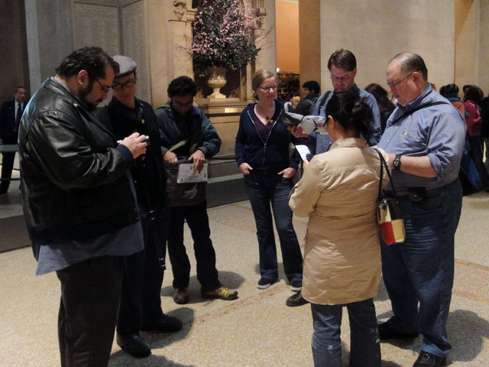
Clockwise from Left: Mike, Robert, Sundar, Caroline, Kai, Barry, Winnie. Jenn arrived slightly later.
In an heroic effort, I managed to run through the Greek/Roman, Asian (South, South East, and Central) and Medieval European galleries. I took 482 photos that day, not knowing exactly what I was looking for. I spent the following week going through each photo, adjusting levels and contrast, and wondering what I'd do with them. Gradually I saw the possibility of animating continuous movements using poses from historical works. The photographs I had weren't sufficient, which led me to return to the Met by myself on January 26. This time I had a better idea of what kind of photos I wanted: "full-body" shots of specific poses. I took 432 more photos, this time covering Egypt, Oceania, and the Americas.
914 photos total. I carefully examined and adjusted almost every one. 435 of them made it into a folder called "Poses," where I sorted them into categories: Standing, Sitting, Kneeling, Walking, Couples, Dancing, Running, Angels, Christ/Cross, Madonnas, Animals, and Other. Some of those categories obviously didn't make it into the finished movie; for example, these Madonnas:
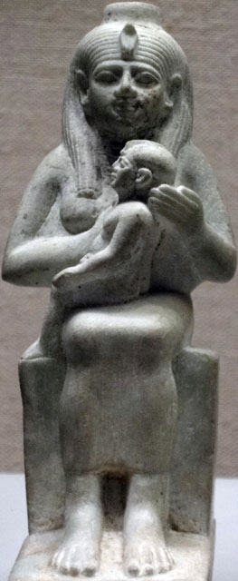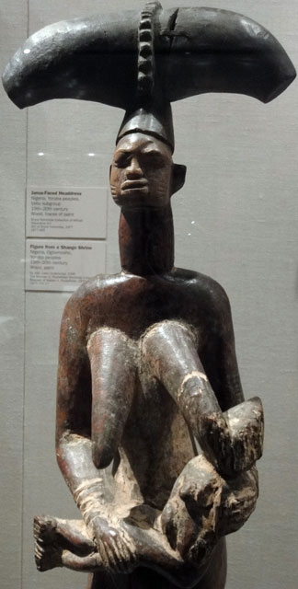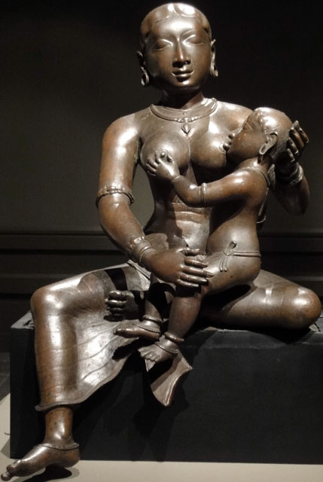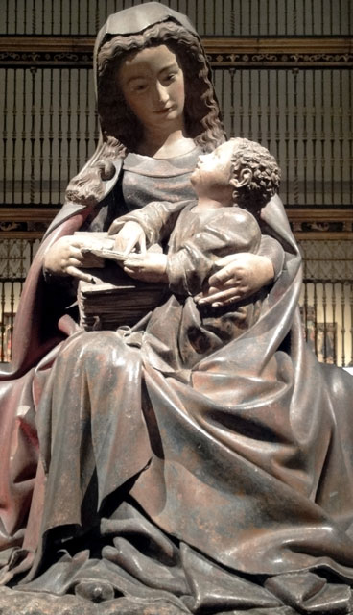
Once I sorted the poses, I masked them in Flash (tracing by hand with my trusty Cintiq stylus) to give them a clean vector edge. If I'd removed the backgrounds in Photoshop, they'd have pixellated edges, which would look "buzzy" in the finished animation.
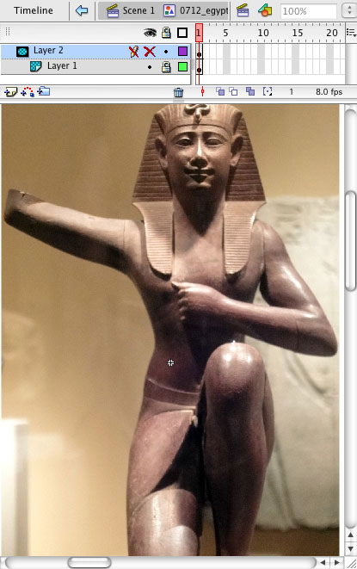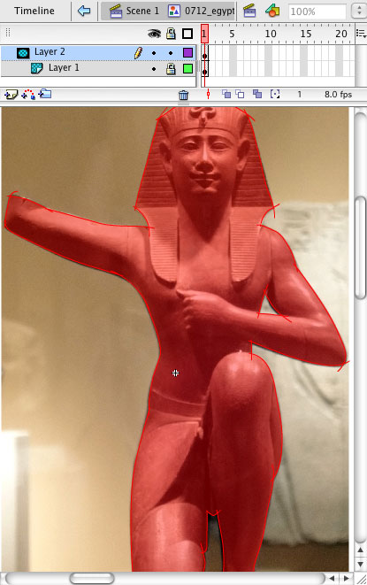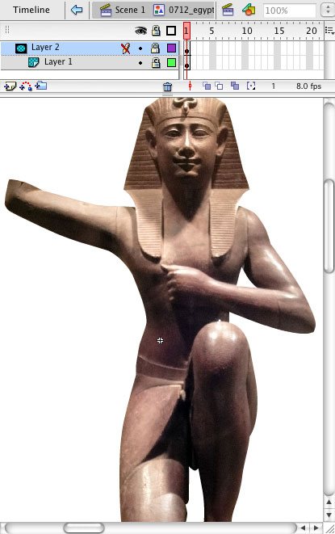
Although I didn't mask all of the photos, I did mask many I didn't end up using. But once I found the right ones, it was pretty easy to put everything together. 112 photos made it into the finished piece (my counting is fallible, it may be slightly more or less, but I counted 112 in the Flash file's Library.)
I animated on 3's, meaning 3 frames per image/8 images per second (at 24 frames per second). Usually I animate on one frame per image/24 images per second, so animation-wise, this is in some ways my crudest, choppiest film. But the frame rate needed to be slower to give the eye enough time to see some of the detail in each photograph.
The whole movie is a single "take." There are no cuts, zooms, pans, scene changes, or closeups. It's usually hard to sustain interest without such editing techniques, but in this case they would have confused the eye and muddied up the experience. This movie demands a lot of concentration from the viewer, and too many tricks would distract more than help.
The music is Sita's String Theory by genius Todd Michaelsen, who composed much of the score of Sita Sings the Blues. It is a "bonus track" he contributed to the upcoming official soundtrack CD. While listening through the entire CD master at Greg Sextro's studio, I realized Sita's String Theory would make a fine track for All Creative Work Is Derivative. It was CC-BY-SA licensed already, making it legally compatible with the project. Its beat is a denominator of 24fps, so it would work with my animation. And of course it sounds wonderful.

One person's "influence" is another's "infringement." A time-travelling IP lawyer could find all kinds of infringements at the Met. Greeks, Egyptians, and South Asians influenced each other heavily; was this "borrowing," "stealing," or "copyright infringement?"
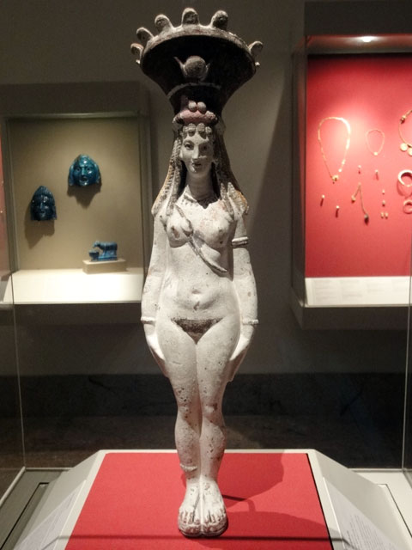
This chick is an Ancient Egyptian!
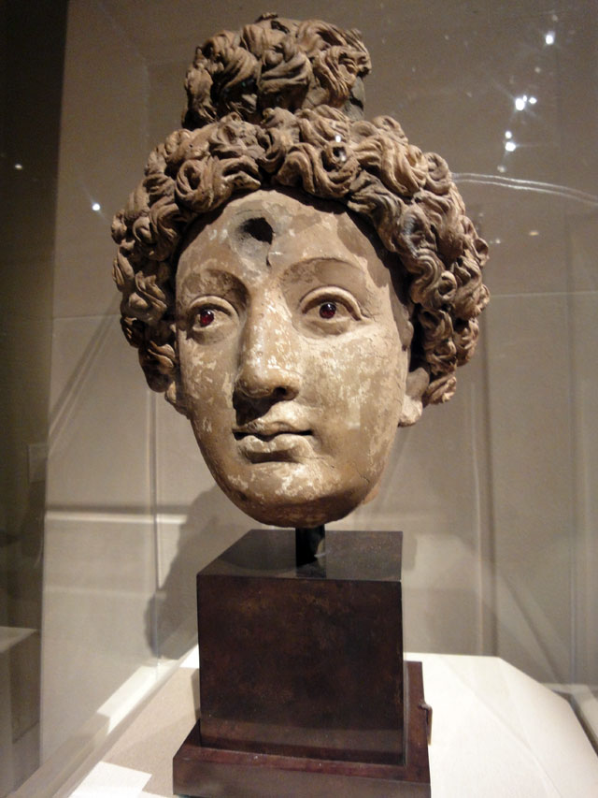
Does this head look Greek to you? Well it's from what is now Pakistan.
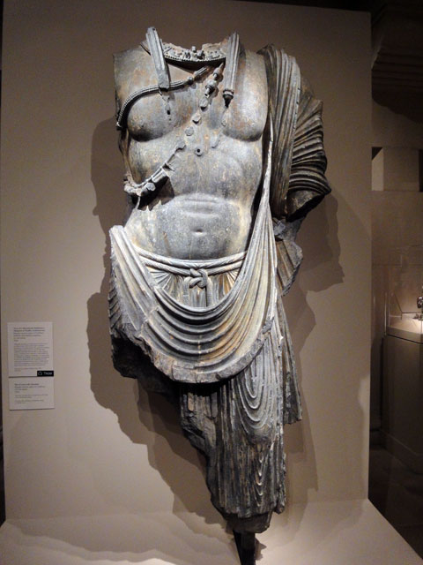
Same with this headless dude.
And whose idea was it to put bird wings on mammals? Could the ancient Egyptians sue the ancient Greeks and Medieval Europeans for trademark infringement?
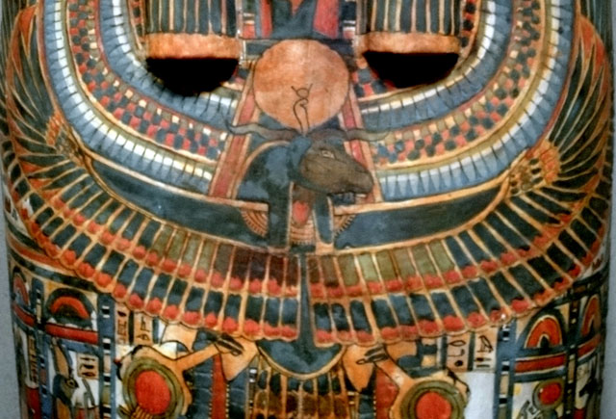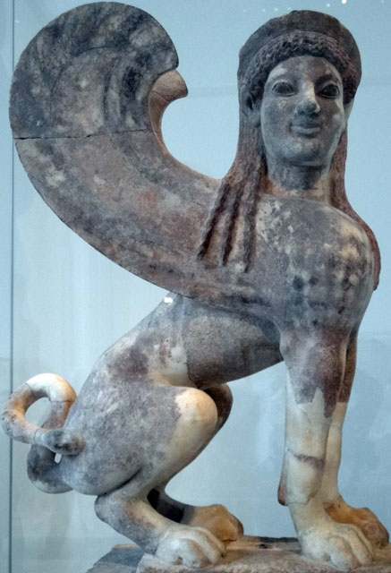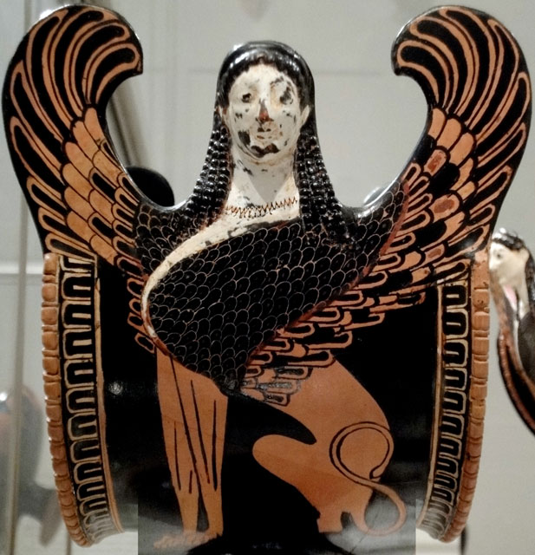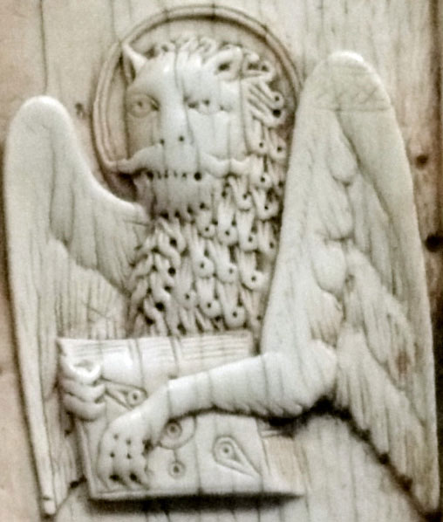
What derivations are transformative? Do we really want lawyers and judges determining what "transformative" is and is not? Do we want cultural progress dictated by the courts at all?
A copyright maximalist would say that this movie is uncreative, as though I used photos of old sculptures because I was too lazy to make my own. I didn't use historical works because I'm lazy. But even lazy artists shouldn't risk lawsuits, fines, and jail.
Or maybe the copyright maximalist would say this movie is creative, because I only photographed non-copyrighted works. But why should the legal status of the work I'm building on have anything to do with how "creative" my work is? The maximalist is working for the day when all works are copyrighted, and all culture is property. No longer shall anyone be able to build on works from the past, be it 5 minutes or 5 millennia ago.
Until that day arrives, I'll see you at the museum.

Hi Cammy,
93
What this article clearly shows is the cultural destruction when the elements of culture are given over artificially, as private property; backed with the force of civil law. As the article states, permutations are made on songs, poems, structures, ideas, et al…these enter into a process of organic growth that is essential for any culture to function wholesomely. The assignment of monopolies to individuals and worse, to corporate overlords who in the end result, function against the interests of the individual, stifles this vital human current. In reality, it is an offense against human nature at just a time when our culture is poised to explode in grand profundity.
93/93
pj

Patently Improper
by Wendy McElroy
If knowledge is power, then ownership of knowledge and its application is an ultimate grasp on power.
President Obama made the overhaul of America’s patent law a personal priority, including it prominently in his January 2011 State of the Union address. The America Invents Act ^{[1]} was signed into law on September 16. The key change is a switch from “first to invent” to “first to file.”
Critics and advocates overwhelmingly focus on the practical implications ^{[2]} of the Act. Fundamental questions about patents are rarely raised. These questions include: What is a patent? Do patents express a natural right or a governmental grant of monopoly?
What Is a Patent?
Patents and copyrights protect what is called “intellectual property.” A patent is an ownership claim to the expression or implementation of an idea. If the idea is an original expression – for example, music – the ownership claim is called copyright. If it is expression through implementation – for example, an improvement to a machine — the claim is called a patent. The holder of a patent can prevent anyone else from identically implementing the same idea. At its root, controversy over intellectual property is about freedom of expression and when it can be properly restricted.
Patents and copyright quickly part company. The most famous libertarian to make a sharp distinction between the two was the single-tax champion Henry George. He rejected the former and embraced the latter.
Why? In his periodical The Standard (June 23, 1888), George explained his objection to patents, “No man can justly claim ownership in natural laws, nor in any of the potentialities which nature hold for it.” A patent involves identifying and using a law of nature or a fact of reality, neither of which have been created by the discoverer.
Discovery versus Production?
George distinguished between two forms of labor involved in invention. The first was the mental labor of working out operating principles: discovery. The second form was the construction of a specific machine or implementation: production.
Since the principles discovered were preexisting – such as how X amps of electricity react to Y ohms of resistance — they should be available for anyone to use and not monopolized by one man. To the argument that specific implementations – such as voltmeters — did not exist in nature and so could be patented, George replied that the principles on which machines operated were intrinsic in nature. A windmill expresses how the force of wind pushing against a particular surface can produce power. Thus every patent amounts to an ownership claim over an expression of nature and the logic of its application. A man could own a specific windmill he produced but he could not prevent others from similarly producing their own windmills.
This is a common distinction between patents and copyright. Patents are an ownership claim over preexisting natural laws and their implementation; copyright is a claim to “goods” with no preexistence.
Simultaneous Discovery
Another argument against patents is that they violate the rights of a simultaneous inventor. Two people can plausibly invent the same thing independently and at nearly the same moment; hence it is not proper for only one to have a monopoly.
Fields of endeavor can reach a stage where certain breakthroughs become almost inevitable. Then it is not uncommon for people independently to develop extremely similar applications. The most famous example may be calculus, developed by both Newton and Leibniz.
This objection to patents was expressed by the nineteenth-century libertarian Benjamin Tucker: “The central injustice of . . . patent laws is that it [sic] compels the race to pay an individual through a long term of years a monopoly price for knowledge that he has discovered today although some other man . . . in many cases very probably would have discovered it tomorrow.”
Obama’s patent “reform” trades one injustice for another. Formerly the first to invent won the patent, even if someone else indisputably did the same thing independently. Now the first to file for a patent will win, similarly excluding independent inventors – not to mention anyone else who tries to use the natural principles as embodied in the invention.
Roots of Patent
Historically patents were grants of privilege awarded by a ruler to his favorites or to those willing to pay bribes. America broke precedent. Article I, Section 8 of the Constitution states, “Congress shall have the power . . . to promote the progress of science and useful arts, by securing for limited times to authors and inventors the exclusive right to their respective writings and discoveries.” The original American patent law thus extended protection in order to encourage innovation. However, one might say that it simply changed the criterion by which monopoly privilege would be granted.
Whether you agree with that original purpose or believe (as I do) that all patents are improper, the America Invents Act is repellent. By granting patents to those who merely file first rather than invent first, Obama further advantages State-privileged corporations with their massive research funds and lawyers, and takes a huge step backward toward the days of patents as royal privileges.

Article printed from The Freeman Online: http://www.thefreemanonline.org
URL to article: http://www.thefreemanonline.org/headline/patently-improper/
URLs in this post:
[1] America Invents Act: http://thomas.loc.gov/cgi-bin/query/D?c112:5:./temp/~c112kTZtES::
[2] practical implications: http://www.law.com/jsp/cc/PubArticleFriendlyCC.jsp?id=1202514170593

WTF?!, No Seriously, WTF! - Bank Of America Holds Patent On 'Changing Your Emotions' During Customer Service Call

SYSTEMS FOR INDUCING CHANGE IN A HUMAN PHYSIOLOGICAL CHARACTERISTIC
Patent Abstract
Systems and methods for inducing a change in a human physiological characteristic. The physiological characteristic may correspond to an emotional state of a dialogue participant. The dialogue participant may be an individual participating in a conversation. The outcome of the conversation may be related to a business objective, such as providing high quality call center services. A sensor may monitor the physiologic characteristic. A processor may relate the physiologic characteristic to an emotional state. The processor may provide feedback to the individual based on the emotional state. The feedback may be formulated to change the individual's emotional state.
- Read the Patent Application HERE
We wonder, do they also have patents on the following:
- Ken Lewis' genius decision to buy Countrywide and assume billions in liability.
- Having the worst customer service of any U.S. bank.
- Overpaying for Merrill Lynch.
- Robbing shareholders.
- Using Repo 105s to hide true balance sheet exposures.
- Foreclosing on homeowners in violation of 400-year-old contract law.
- Destroying lives.
- Losing the mortgage note.
We're certain there are more, but we'll leave it to readers to complete the rest of the BofA patent portfolio in comments.
Hi All,
93
This article perfectly dramatizes the problem of IP.
In Thelema, IP is serving to bring our spiritual system down into the mundane and has led to more quarrels than cooperation.
This means that IP is making the Thelemic community imbalanced, which ultimately, could neutralize us altogether.
If you really want to see this spiritual system have an effective impact on human culture, do everything you can to violate all Thelemic copyrights.
One cannot own a thought or an idea…it’s overtly ridiculous.
If someone can copyright or trademark changing emotions during a business conversation, you gotta wonder, will they also copyright loud farts during commercial transactions. Then, if someone farts in this situation, the copyright/trademark owner can sue???!!!
The result of changing emotions during a customer service call being patented would mean that only BofA can allow their customer service staff to be emotional; the rest of the world will be better off hiring robots…less they get sued for competing with BofA. BofA would then become a monopoly. And monopolies destroy human initiative…just as the Caliphates (and others) enforcement of copyrights destroys spiritual growth in the Thelemic community.
So again, I urge you for my own benefit, republish all of my writings and websites…they’re not copywritten. Please, make my voice even louder and let the mountains themselves bring new Gnosis to the world.
For all the ‘shut ups’ (cf. Book of Lies, cap 89) who enforce copyrights…let’s start calling them anti-Thelemites. For that is what they are…little children who have not learned to share and really place no value in the human race.
93/93
pj

What Makes Ideas Different?
Mises Daily: Thursday, September 29, 2011 by Leonard Read
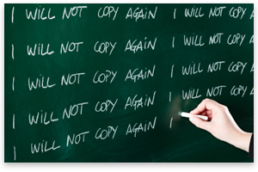
"There is a difference between imitating a good man and counterfeiting him."
Benjamin Franklin
[To Free or Freeze (1972)]
The dictionary defines plagiarism: "to take and pass off as one's own (the ideas, writings, etc. of another)."
At first blush, the plagiarist appears to be a despicable cad — nothing less than a thief. But perhaps this is too hasty a judgment.
What makes plagiarism a vice is knowingly to pass off as one's own the ideas and writings of another, that is, to make a liar of self. For it is easily demonstrable that practically every idea we espouse and pass off as our own is unknowingly taken from others. Indeed, were this not the case, that is, were we to traffic exclusively in our own original ideas and writings — ideas never thought of by anyone else before — communication would come to a near halt. A few observations on this point:
- Originality is nothing but judicious imitation. The most original writers borrowed one from another. The instruction we find in books is like fire. We fetch it from our neighbors, kindle it at home, communicate it to others, and it becomes the property of all.
- One couldn't carry on life comfortably without a little blindness to the fact that everything has been said better than we can put it ourselves.
- People are always talking about originality; but what do they mean? As soon as we are born the world begins to work upon us; and this goes on to the end. And, after all, what can we call our own except energy, strength, and will? If I could give an account of all that l owe to great predecessors and contemporaries, there would be but a small balance in my favor.
- Originality is simply a pair of fresh eyes.
- If we can advance propositions both true and new, these are our own by right of discovery; and if we can repeat what is old, more briefly and brightly than others, this also becomes our own, by right of conquest.
- It is almost impossible for anyone who reads much, and reflects a good deal, to be able, on every occasion, to determine whether a thought was another's or his own. I have several times quoted sentences out of my own writings, in aid of my own arguments, in conversation, thinking that I was supporting them by some better authority!
- Those writers who lie on the watch for novelty can have little hope of greatness; for great things cannot have escaped former observation.
- It is not strange that remembered ideas should often take advantage of the crowd of thoughts and smuggle themselves in as original. Honest thinkers are always stealing unconsciously from each other. Our minds are full of waifs and strays which we think our own. Innocent plagiarism turns up everywhere. Literature is full of coincidences. There are thoughts always abroad in the air which it takes more wit to avoid than to hit upon.
- Plagiarists have, at least, the merit of preservation.
The background of these nine observations has an interesting instruction for us. Upon deciding to explore this topic, I turned to The Dictionary of Thought, selecting the quotations which more or less squared with my own thinking on originality and plagiarism, opinions I believed to have been more or less my own. Not one of these observations am I aware of having read before. Now, had I not discovered what others had written and had I put these same thoughts in my own phrasing, I would have been unknowingly taking from others. Not a thing wrong with that — nothing, whatsoever; it would have had "at least the merit of preservation." On the other hand, suppose that after discovering these observations I had used the exact phrasing and claimed them as my own! What a liar! Such a tactic would have done no harm to those authors who live only in our memory and no offense to my readers. Just self-injury!
Finding the original of a given idea probably is not possible. For instance, in October 1970 a book of mine was published entitled Talking to Myself. Some months later, the celebrated Pearl Bailey's Talking to Myself was announced. It is a reasonable certainty that neither of us took the title from the other; it simply occurred to both of us at the same time. Such is the synchronistic nature of ideas occurring to different minds simultaneously. The record is studded with examples. The Swiss psychiatrist, Carl Jung, wrote a book on this phenomenon: Synchronicity.
Equally phenomenal is the way in which ideas develop. We hear or read an idea new to us. It insinuates itself into the subconscious or some womb of the mind, goes through a period of gestation for days, weeks, or years and, if it does not die in embryo, emerges as one's very own — an "original." I have been able to identify such "originals" in my own experience, the gestation periods ranging from six months to thirty years.
There is, in fact, no way to fasten ownership claims to an idea, which is spiritual, as we do with material things — copyright laws and legal jargon to the contrary notwithstanding. Might as well try to draw property lines around a cloud or a wish or a dream or Creation. Ideas are forever in a state of fusion and/or flux, and they defy any precise earmarking.
One might conclude that this evaluation is at odds with the free-market, private-ownership way of life which, of course, lays stress on the profit motive — and, quite properly. This, however, is to gloss over the fact that there are two kinds of profit: psychic and monetary, the former being no less a motivator of creative action than the latter. And no less rewarding!
Robert Louis Stevenson gave us this aphorism: "I take my milk from many cows but I make my own butter." And I do precisely the same, my "butter" being a nonprescriptive philosophy: no man-concocted restraints against the release of creative energy.
Do I resent the taking and using of my ideas by others? To the contrary, the more others adopt them the greater is my satisfaction: psychic profit. Suppose my ideas on liberty were so widely accepted by others that freedom might prevail as our way of life. I would prefer this above all the dollars in Christendom. And as for credit, I couldn't care less. Personal fame is of small consequence in contrast with individual liberty and equal opportunity for all, even from the standpoint of pure self-interest. I fare well precisely because others do.
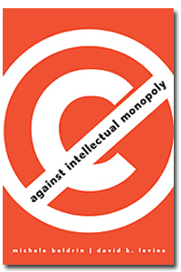
"Might as well try to draw property lines around a cloud …"
And speaking of fare, one of my hobbies is cooking. I have taken my milk from many cows — culinary artists — but now and then "ad lib," adding a spice or herb or a touch of this and that which imparts gastronomic novelty. When an appreciative guest expresses a desire for the recipe, it is given with the greatest of pleasure; never withheld as my monopoly. First, there is a psychic profit in this giving, sufficient unto itself. And, second, should I dine at that other person's table, his or her best fare will be served to me.
The same principle of exchange and sharing elevates ideas just as it improves the quality of food. The more I share ideas with others, the more and better are my own, and the better are the ones offered to me. This is the process of putting the best foot forward.
Ideas come from we know not where; they are of a spiritual nature. When we receive and understand them they are ours or, perhaps, it would be more accurate to say we are theirs. In any event, good ideas are not to be put in storage but are to be shared — as freely given as received.
Leonard E. Read was the founder of the Foundation for Economic Education — the first modern libertarian think tank in the United States — and was largely responsible for the revival of the liberal tradition in post–World War II America. Mises.org will be putting all of his books online for free. See them all here. See Leonard Read's article archives.

